***Characterization of Marker Compounds in Curcuma zanthorrhiza Using NMR***

Alanindra Saputra1, Yudi Rinanto1, Joko Ariyanto1, Dinar Sari C2, Binti Q1

1). Biology study program, FKIP UNS

2). Pharmacy study program, FMIPA UNS

**Abstract**

*Curcuma zanthorrhiza* is a plant from the family *Zingeberaceae* that grows in Indonesia. This plant is widely used as traditional medicine, spices of food, beverages, cosmetics and coloring agents, especially food coloring. The research was conducted using a complete random factorial design with 3x3 repliation. The treatments are curcuma varieties (V) from Malang, Blora and Sukoharjo and drought stress (K) namely every day, two days and three days watering. The aim of the research was to determine the different response of curcuma for agronomic character and metabolites compound on drought stress treatment. Drought stress treatment (K) showed significant results on curcuma plant height. K3 treatment (three days watering) has a negative effect on plant height. Sukoharjo variety with every day watering produces the best rhizome weight compared to two other varieties. Secondary metabolites of xanthorrhizol and curcumin can be identified used NMR analysis in the Sukoharjo variety ginger rhizome with a relative concentration of 1.25 ± 0.46 and 1.53 ± 0.54.

**Keywords: curcuma, drought stress, metabolite, NMR**

**INTRODUCTION**

*Curcuma zanthorrhiza* is a plant from the *Zingeberaceae* tribe that grows in Indonesia. This plant is widely used as traditional medicine, spices of food, beverages, cosmetics and coloring agents, especially food coloring. To meet these commodities, demand for ginger materials reaches 3000 tons / year and continues to increase every year. For health, ginger has the potential as an anti-inflammatory, anti-immunodeficiency, antiviral, anti-bacterial, anti-fungal, anti-oxidant, anti-carcinogenic and anti-infectious agent (Araujo and Leon, 2001; Chattopadhyay et al., 2004; Joe et al., 2004). Curcuminoids are secondary metabolites of diferuloymethane which are widely reported as active compounds in ginger (Aggarwal et al., 2005).

The content of secondary metabolites is strongly influenced by various environmental factors including climate which includes light, air temperature, and humidity. The chemical and physical properties of the soil and the availability of water in the soil also affect the rooting environment. Therefore, local farmers have difficulty supplying ginger as raw material in the drug industry due to secondary metabolite content, especially the content of curcumin and fluctuating material quality. Therefore, standardized ginger quality is very necessary. Wardiyati at al (2010) reported that the ginger collection of Java and Madura produced the highest curcumin compared to ginger growing in other regions. Thus, this study is the starting point of high and stable curcumin-producing ginger cultivation which is very necessary as a raw material for the drug industry.

Metabolomics is a holistic method that provides an overall picture of both primary metabolites and secondary metabolites in a biological system (Clayton et al., 2006). Many different methods in terms of sensitivity can be used to analyze the metabolite content of plants. One method that has the potential to meet the above mentioned criteria is nuclear magnetic resonance spectroscopy (NMR). NMR has been used extensively as a tool to analyze the chemical profile of a plant using the multivariate data analysis method where one of the commonly used methods is the principal components analysis (PCA) (Sumner et al., 2003). Recently, a combination of NMR and PCA is widely applied to analyze the chemical content profile of some plants (Belton et al., 1998; Charlton et al., 2002). This method has proven to be an appropriate tool for characterizing the chemical content of several species (Choi et al., 2005; Kim et al., 2005) and cultivars (Choi et al., 2004). However, the literature on metabolomic studies using NMR has not been reported.

**RESEARCH METHODS**

The first year study was carried out in the experimental garden of the Faculty of Agriculture, Sebelas Maret University, Surakarta. Profiles of primary metabolites and secondary Curcuma cultivars from each region were carried out using NMR at the UNS MIPA Central Laboratory. Curcumin marker compounds which have high curcumin content were carried out using SIMCA-P software, version 12.0 Umetrics, Umea, Sweden.

The study was carried out using an experimental method using a basic randomized complete design. Drought Stress Treatment (K) consists of 3 levels as follows:

K1 = daily watering plants (Control)

K2 = every two days watering plants

K3 = every 3 days watering plants

Water volume every time watering is 100 ml. The stress treatment is carried out for 2 months and is done after the plant is 4 months old. Since planting up to 4 months old plants, all plants are treated with standard treatment and regular watering every morning with the same amount of water for all plants, which is 100 m. Curcuma rhizome is grown on a 10 kg polybag. Each treatment was repeated 10 times. The shade material uses black silver plastic

**Observation of agronomic components**

1. Plant height (cm), measured starting from the base of the stem to the highest tip of the leaf

2. Number of Bulbs, measured the number of rhizomes formed including the main rhizome

3. The weight of the rhizome, weighed all the rhizomes produced after being cleaned from the remnants of the soil attached to the surface of the rhizome

Agronomic observation data was analyzed using a two-way variant analysis, followed by a midpoint test of the BNT (Smallest Real Difference)

**Extraction**

Samples of rhizomes that have been harvested, cleaned, cut into small pieces and blended to a small size. Blended rhizomes are put into a pot of ointment and put into a deep freezer with a temperature of -20° C for 3 x 24 hours. The frozen rhizome is then put into a freeze dryer at a temperature of -108° C for 4 x 24 hours (Kim et al., 2010). The dried rhizome samples were then grinded to a fine powder. A fine powder of 30 mg was put into a 2 ml eppendrof tube then added 270 µl of phosphate buffer mixture (KH2PO4) in deuterium oxide containing 0.01% TSP and 630 µl CD3OD with a ratio of 3: 7. The mixture was mixed (1 minute, room temperature), authenticated (20 minutes, room temperature) and centrifuged (13,300 rpm, 28oC, 10 minutes). The supernatant obtained from the centrifugation was transferred to a new eppendrof tube, then measured.

A supernatant of 600 µl was put into a 5 mm NMR tube for 1H-NMR analysis. The 1H-NMR spectra were recorded at 25 oC using Agilent P 400 MHz 1H-NMR spectroscopy. TSP (sodium salt of 3 (trimethylsilyl) -propionate acid-d4) is used as an internal standard. The sample is read on spectral width -1.0 to 11.0 ppm. Measuring 1H-NMR spectra was 128 scans with the following parameters: presaturation delay 2 seconds, acquisition time 3,408 seconds, relaxation delay 2 seconds, observe pulse = 6, 8 µs (90o). Presaturation is used to suppress H2O residues. Spectra results were manually carried out baseline correction and calibration using TSP on 0.00 ppm chemical shift.

2D NMR *J-resolved* spectra are performed with 8 scans per 64 increments with 1 second relaxation delay and 0.625 seconds acquisition time. Spectra *J-Resolved* tilted (tilted) 45o and symmetricized, then calibrated using TSP at a chemical shift of 0.00 ppm. COSY (Homonuclear Correlation Spectroscopy) is performed with 1 second relaxation delay, spectral width of 512 Hz in F1 and 4807.7 Hz in F2. All spectra are carried out manually by baseline correction and internal standard calibration (TSP = 0.00 ppm).

**Measurement of secondary metabolites using NMR**

A supernatant of 600 µl was put into a 5 mm NMR tube for 1H-NMR analysis. The 1H-NMR spectra were recorded at 25 oC using Agilent P 400 MHz 1H-NMR spectroscopy. TSP (sodium salt of 3 (trimethylsilyl) -propionate acid-d4) is used as an internal standard. The sample is read on spectral width -1.0 to 11.0 ppm. Measuring 1H-NMR spectra was 128 scans with the following parameters: presaturation delay 2 seconds, acquisition time 3,408 seconds, relaxation delay 2 seconds, observe pulse = 6, 8 µs (90º). Presaturation is used to suppress H2O residues. Spectra results were manually carried out baseline correction and calibration using TSP on 0.00 ppm chemical shift.

2D NMR *J-resolved* spectra are performed with 8 scans per 64 increments with 1 second relaxation delay and 0.625 seconds acquisition time. Spectra *J-Resolved* tilted 45º and symmetricized, then calibrated using TSP at a chemical shift of 0.00 ppm.

COSY (Homonuclear Correlation Spectroscopy) is performed with 1 second relaxation delay, spectral width of 512 Hz in F1 and 4807.7 Hz in F2. All spectra are carried out manually by baseline correction and internal standard calibration (TSP = 0.00 ppm).

**DISCUSSION**

Testing of the average value of plant height, rhizome weight, and number of tillers as shown in the following table 1:

Table 1. Testing the average value

|  |  |  |  |
| --- | --- | --- | --- |
| Treatment | Plant height  (cm) | Rhizome Weight  (gr) | Number of Rhizomes |
| M | 311 c | 3,85 a | 17 a |
| S | 320 b | 4,32 cb | 47 c |
| B | 306 a | 4,08 b | 29 b |
| K1 | 361 c | 4,26 cb | 46 c |
| K2 | 298 b | 4,12 b | 29 b |
| K2 | 280 a | 3,87 a | 18 a |

Information :

M: Curcuma variety from Malang

S: Curcuma Varieties from Sukoharjo

B: Curcuma variety from Blora

K1: every day watering (control)

K2: every two days watering

K3: every 3 days watering

The response of the three Curcuma varieties to the treatment of water is different. Varieties from Sukoharjo showed better plant height, rhizomeweight and rhizomes than varieties from Malang and Blora.

The K1 treatment gave the greatest influence on plant height followed by K2 and K3 treatment. Provision of water that is carried out every day produces a positive influence on the plant's high components. The amount of water available continuously in the final phase of Curcuma growth can maintain the supply of elements from the root area can still be maintained by plants, so that the growth process takes place well.

The K1 treatment gives the best effect on the rhizome's western observations, although it is not different from the K2 supply. The Sukoharjo variety produces the largest rhizome weight and the highest number of tillers compared to two other varieties. This is possible because the planting is done in the Sukoharjo area, so that the variety has a better adaptation than the others.

Identification of the main secondary metabolites namely xanthorrhizol and curcumin in the rhizome of Curcuma Sukoharjo.

**Identification and quantification of secondary metabolites with NMR**

The xanthorrhizol proton signal in C. xanthorrhiza Roxb. can be detected in 1H-1H J-resolved at 87H 1.87 ppm (s) (H-12), δH 1.93 ppm (s) (H-13), δH 2.00 ppm (s) (H-14 ), δH 1.22 ppm (d, J = 7.06 Hz, H-15), δH 2.69 ppm (q, J = 7.35 Hz, H-7), δH 7.23 ppm (d, J = 3.05 Hz, H-2), δH 7.57 ppm (dd, J = 8.21; 3.16 Hz, H-6), and at δH 6.89 ppm (d, J = 8, 59 Hz, H-5). In 1H-1H COSY there was a correlation between protons at δH 1.22 ppm (H-15) and δH 2.69 ppm (H-7), and protons at δH 6.89 ppm (H-5) and δH 7.57 ppm (H-6). The xanthorrhizol proton signal in the 1H-1H *J-resolved* and 1H-1H COSY spectra of *C. xanthorrhiza* is shown in Figure 1.

Curcumin compounds in *C. zanthorrhiza* Roxb. shown by the proton signal H-7/7 'appears at δH 3.92 ppm as singlet because it does not have a neighboring proton atom. Proton H-3/3 'appears at δH 6.64 ppm (d, J = 15.68 Hz) and the proton signal at H-4/4' appears at 7H 7.57 ppm (d, J = 15.68 Hz) 1H-1H COSY data on H-3/3 'has a correlation with δH7.57 ppm (H-4/4'). The proton signal H-9/9 'appears at δH 6, 89 ppm (d, J = 8.59 Hz), the signal appears as a doblet with J 8.59 Hz because protons at H-9, 9' have one neighboring proton ortho position. The proton H-10/10 'signal appears at 15 7.15 ppm (dd, J = 8.21; 3.16 Hz). These signals appear as large and small double lobes because the protons H-10/10 'have each of the neighboring protons in the ortho and meta positions. Proton on H-9/9 'in 1H-1H COSY has a correlation with protons on H-10/10'. 1H-1H J-resolved and 1H-1H COSY curcumin from *C. xanthorrhiza* extract can be seen in Figure 2.

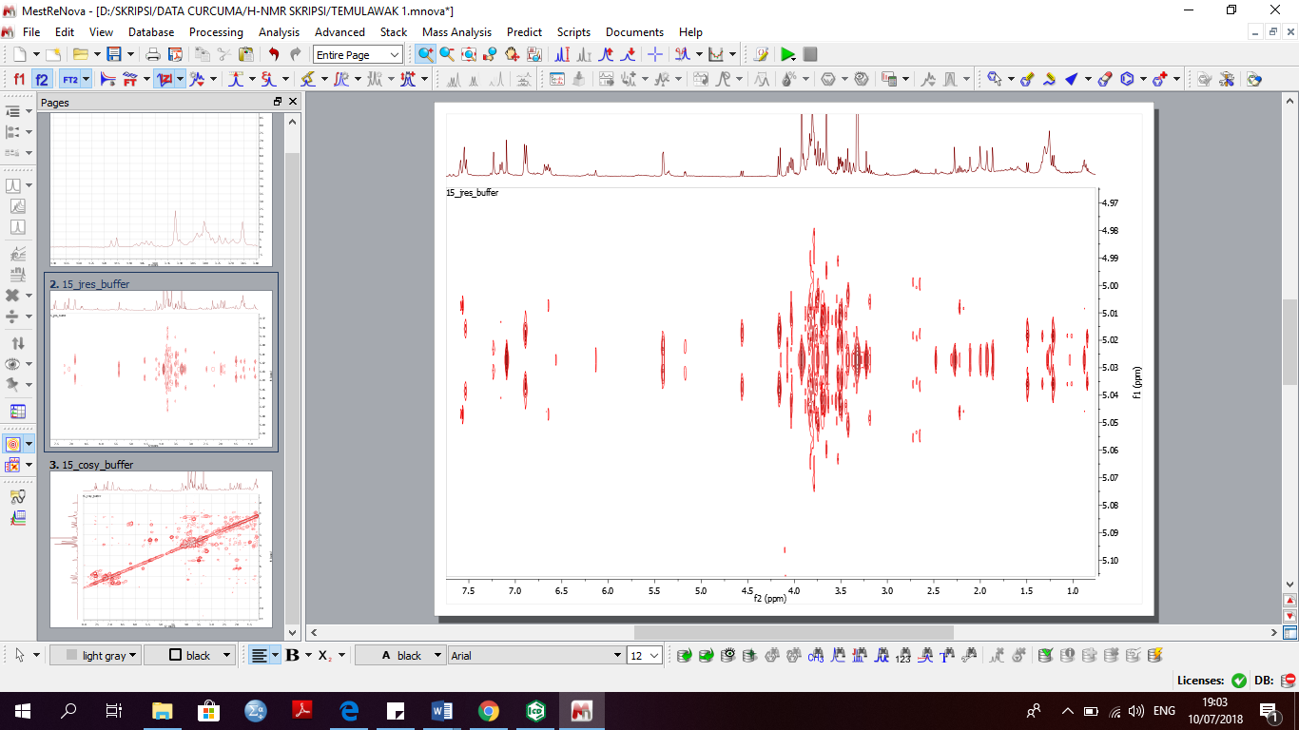

1,22 ppm

(*d*, *J* = 7,06 Hz)

1,93 (*s*)

1,87 (*s*)

2,00 (*s*)

2,69 ppm

(*q*, *J* = 7,35 Hz)

6,89 ppm

(*d*, *J* = 8,59 Hz)

7,23 ppm

(*d*, *J* = 3,02 Hz)

7,57 ppm

(*dd*, *J* = 8,21; 3,16 Hz)

A

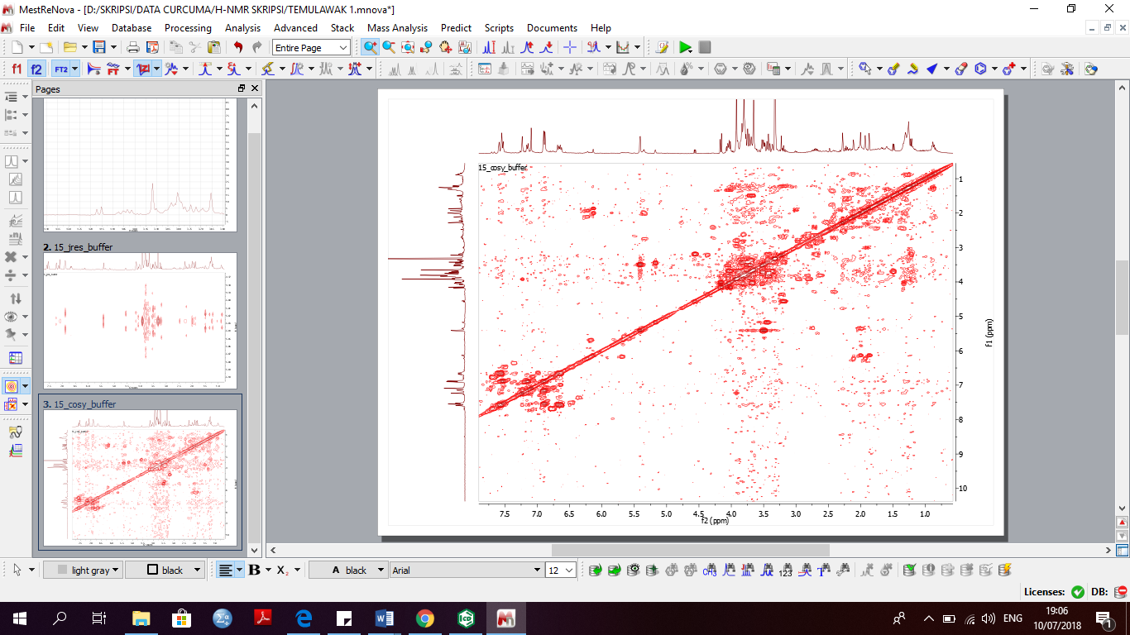

1

2

H-15

H-7

H-5

H-6

B

**Figure 1**. Spectra proton xanthorrhizol on *C. xanthorrhiza* Roxb.(A) 1H-1H *J-resolved*. (B) Spectra 1H-1H COSY shows the correlation between protons H-15 and H-7 (1), correlation between protons H-5 and H-6 (2).

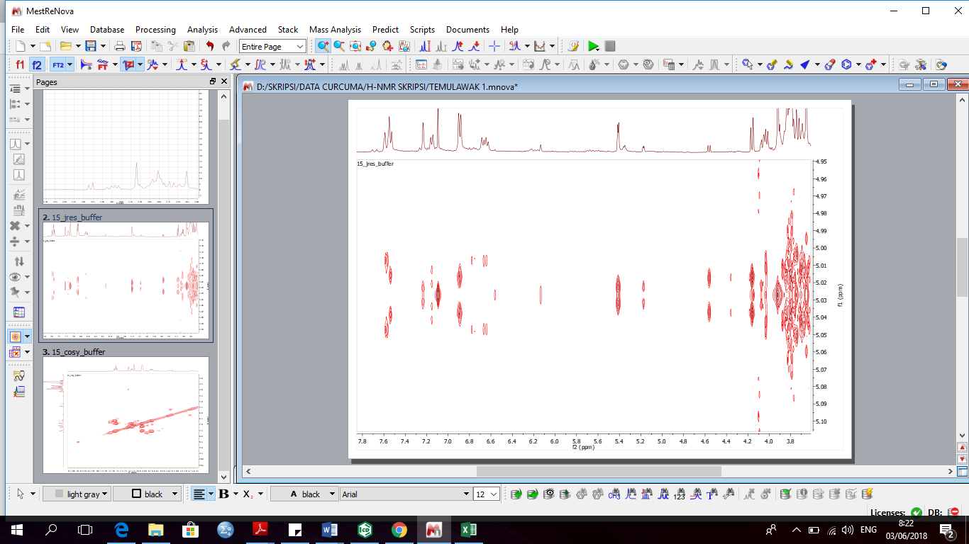

3,92 (*s*)

6,64 ppm

(*d*, *J* = 15,68 Hz)

6,89 ppm

(*d*, *J* = 8,59 Hz)

7,57 ppm

(*d*, *J* = 15,68 Hz)

7,15 ppm

(*dd*, *J* = 8,21; 3,16 Hz)

A

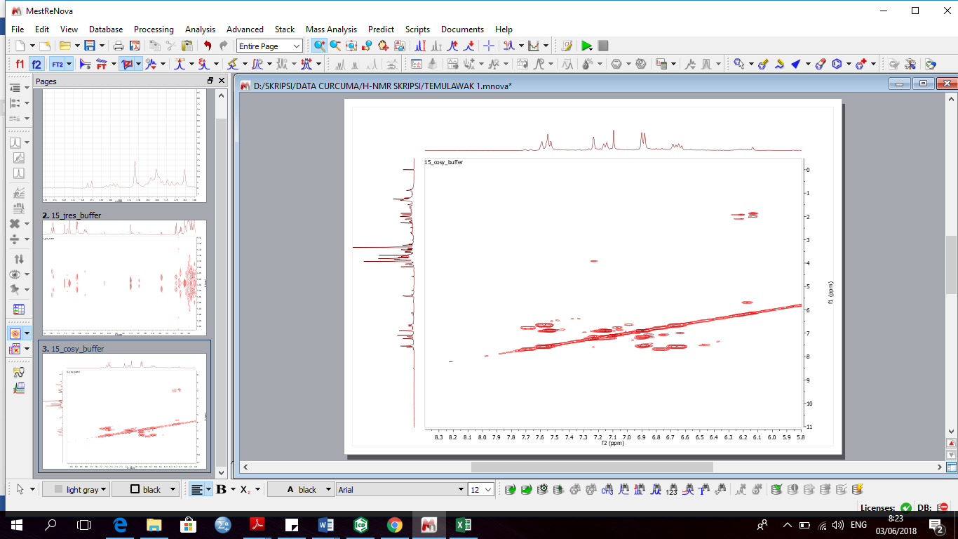

1

H-3/3’

H-4/4’

2

H-9/9’

H-10/10’

B

**Figure 2**. Proton curcumin spectra on *C. xanthorrhiza* Roxb.(A) 1H-1H *J-resolved*. (B) Spektra 1H-1H COSY shows the correlation between protons H-3/3’ and H-4/4’ (1), correlation between protons H-9/9’ and H-10/10’ (2)

Quantification of xanthorrhizol and curcumin in the Sukoharjo ginger rhizome can be seen in Figure 3. The two secondary metabolites have been identified by previous studies on ginger (Rafi *et al.*, 2015; Lechtenberg, Quandt and Nahrstedt, 2004). The results showed that the curcumin content was higher than xanthorrhizol content. Xanthorrhizol is the main compound in ginger (Ab Halim *et al.*, 2012). However, Jarikasem et al. (2003) reported that xanthorrhizol could not be identified in ginger from Thailand. This difference is probably caused by differences in the age of the rhizome harvest. The optimum abundance of xanthorrhizol is at 12 months of planting (Endrasari and Mas’adi, 2011).

**Figure 3.** Quantification of xanthorrhizol and curcumin identified in the extract of *C. xanthorrhiza* Roxb analyzed by 1H-NMR.

**CONCLUSION**

Based on the data obtained from agronomic components and metabolites using NMR it can be concluded that drought stress treatment (K) showed significant results on the height of ginger plants. K3 treatment (watered once every two days) has a negative effect on plant height. Sukoharjo variety with watering every day produces the best rhizome weight compared to two other varieties. NMR-based metabolomic method can be used as a differentiator for the presence of metabolites in ginger.

**BIBLIOGRAPHY**

Aggarwal, B. B., Kumar, A., Aggarwal, M. S., Shishodia, S., 2005. Curcumin derived from turmeric (*Curcuma longa*): a spice for all seasons. Phytopharmaceuticals in Cancer Chemoprevention 23, 351-387.

Araujo, C., Leon, L., 2001. Biological activities of *Curcuma longa* L. Memorias do Instituto Oswaldo Cruz 96, 723-728.

Belton, P. S., Colquhoun, I. J., Kemsley, E. K., Delgadillo, I., Roma, P., Dennis, M. J., Sharman, M., Holmes, E., Nicholson, J. K., Spraul, M., 1998. Application of chemometrics to the 1 H NMR spectra of apple juices: discrimination between apple varieties. Food Chemistry 61, 207-213.

## Bisnisfarmasi. 2007. Pasar Biofarmaka; WOW! ( Bagian 1&2) http://bisnisfarmasi.wordpress.com/2007/02/19/pasar-biofarmaka-wow-bagian-1&2/

Charlton, A. J., Farrington, W. H., Brereton, P., 2002. Application of 1H NMR and multivariate statistics for screening complex mixtures: quality control and authenticity of instant coffee. Journal of Agricultural and Food Chemistry 50, 3098-3103

Chattopadhyay, I., Biswas, K., Bandyopadhyay, U., Banerjee, R. K., 2004. Turmeric and curcumin: Biological actions and medicinal applications. Current Science 87, 44-53.

Choi, Y. H., Kim, H. K., Hazekamp, A., Erkelens, C., Lefeber, A. W., Verpoorte, R., 2004. Metabolomic Differentiation of Cannabis s ativa Cultivars Using 1H NMR Spectroscopy and Principal Component Analysis. Journal of Natural Products 67, 953-957.

Choi, Y. H., Sertic, S., Kim, H. K., Wilson, E. G., Michopoulos, F., Lefeber, A. W., Erkelens, C., Prat Kricun, S. D., Verpoorte, R., 2005. Classification of Ilex species based on metabolomic fingerprinting using nuclear magnetic resonance and multivariate data analysis. Journal of Agricultural and Food Chemistry 53, 1237-1245.

Clayton, T. A., Lindon, J. C., Cloarec, O., Antti, H., Charuel, C., Hanton, G., Provost, J.-P., Le Net, J.-L., Baker, D., Walley, R. J., 2006. Pharmaco-metabonomic phenotyping and personalized drug treatment. Nature 440, 1073-1077.

Dalimantha, S., 2000, *Atlas Tumbuhan Obat Indonesia, jilid II*, Trubus Agriwidya*.*

Gzik, A. 1996. Accumulation of proline and pattern of α-amino acids in sugar beet plants in response to osmotic, water and salt stress. Env. & Exp. Bot. 36 : 29-38

Holmberg, N. and L. Bulow. 1998. Improving stress tolerance in plants by gene transfer. 3(2) : 61-71

Ihsan, Nana, Anang. 2007**.** Temulawak Dan Kunyit Sembuhkan Hepatitis. <http://www.jamuiboe.com/artikel04.php>

Joe, B., Vijaykumar, M., Lokesh, B., 2004. Biological properties of curcumin-cellular and molecular mechanisms of action. Critical Reviews in Food Science and Nutrition 44, 97-111.

Kim, H. K., Choi, Y. H., Erkelens, C., Lefeber, A. W., Verpoorte, R., 2005. Metabolic fingerprinting of Ephedra species using 1H-NMR spectroscopy and principal component analysis. Chemical and Pharmaceutical Bulletin 53, 105-109.

Levitt, J. 1980. Responses of plants to environmental stresses. Vol.II. Water, radiation, salt and other stresses. Ac. Press.

Prasetiyo.Y.T., 2003, *Instan Jahe, Kunyit, Kencur dan Temulawak,* Kanisius, Yogyakarta.

Rinanto, Y. Sunarni, T dan Levina, F. 2010. Kandungan Kurkumin Kultivar Temulawak Di Wilayah Jawa dan Madura. (*in press*).

Rukmana, R., 1995, *Temulawak Tanaman Rempah dan Obat*, Kanisius, Yogyakarta.

Sidik, M.W. dan Ahmad M., 1994 *Temulawak ( Curcuma xanthoriza, Roxb ) Pengembangan Obat Bahan Alam*, Phyto Medica, Jakarta.

Stahl, Egon, 1985, *Analisis Obat secara Kromatografi dan Mikroskopi*, Institut, Teknologi Bandung. Bandung.

Stahl, E.,1969, *Thin Layer Chromatografi Laboratory Hand Book*, Toppan Company, Tokyo.

Sumner, L. W., Mendes, P., Dixon, R. A., 2003. Plant metabolomics: large-scale phytochemistry in the functional genomics era. Phytochemistry 62, 817-836.

Tardieu, F. 1996. Drought Perception by Plants. Do Cells of Droughted Plants Experience Water Stress?. Plant Growth Regulation 20 : 93-104

Taylor, C.B. 1996. Prolin and water deficit ; ups, downs, ins, and outs. The plant cell. 8 : 1221-1224

Wardiyati, T. Rinanto,Y. Sunarni. T dan Azizah, N. 2010. Identifikasi hasil dan Kurkumin Pada Temulawak (*Curcuma xanthorrhiza* Roxb.) dan Kunir ((*Curcuma domestica*  Roxb.) hasil koleksi di Jawa dan Madura. **Jurnal Agrivita**. Fakultas Pertanian Univ.Brawijaya. Vol 32. hal 1 -12.