Species richness and longitudinal distribution of macrobenthos at River Pelus in Banyumas

**Abstract**. There was a degraded ecosystem and an affected decreasing nekton and microbenthos at River Pelus. So far, no publication of macrobenthos is available. The research purpose was to map species richness and longitudinal distribution of macrobenthos. Survey method was taken with stratified random sampling in eight stations and five replicates from May to July 2018. The result showed ten species of macrobenthos. All species belonged to class Malacostraca (four species) and Gastropoda (six species). Of the four species collected in all replicates, *Macrobrachium oenone* categorized as an indicator species that only lived in Station II because there were a boulder substrate and good water quality. In the same class, *M. pilimanus, Parathelpusa bogoriensis,* and *P. convexa* were in all stations, except station V because there were a sand substrate and poor water quality. In station V, there were only two species of gastropod, *Melanoides riquerti* and *Pomacea canaliculata* could live. In general, there were a cosmopolitan species that could live in all substrates and water quality such as *M. riquerti*. For a longitudinal distribution map, there was a unique tendency of decreasing species richness number due to the river weir.

1. Introduction

Identifying biodiversity value with characters could be seen as placing the traditional levels of biodiversity, such as genes, species, and ecosystems. The species is as the fundamental unit of information on biodiversity management. Longitudinal distribution may describe why species richness changes and useful for the scientific foundations [1].

There is much information on the biodiversity of some rivers. River Pelus has 19.8 km in length from upstream to downstream. The upstream is from Mount Slamet in Baturaden District, Banyumas Regency. It empties at River Klawing. The last river empties at River Serayu. All these rivers are in the Serayu Catchment Area in Central Java. Unfortunately, there were some pollutions in settlement areas [2], especially downstream areas [3]. Many types of research explained a degraded ecosystem and affected a decreasing of nekton such as water quality at River Pelus [2,4]; the impact of introduced fish on Cyprinidae fish diversity [5]; and the indigenous and introduced fish diversity [6]. Research of microbenthos already done, such as microbenthic diatom abundance at River Pelus [3].

In other countries, some researchers reported macrobenthos such as decapod species richness in some stream and rivers [7,8,9,10,11]. Up to now, there is no publication of macrobenthos in this river, especially macrobenthos species richness and their longitudinal distribution. Based on this background, the research purpose was to map species richness and longitudinal distribution of macrobenthos at River Pelus in Banyumas.

1. Methods

## Sampling methods

Research method was survey with stratified random sampling at eight stations at River Pelus in Banyumas Regency from Mount Slamet in the north side with a coordinate of 7°20’06.74” S 109°14’31.64” E to River Klawing in the southeast side with a coordinate of 7°28’24.75” S 109°18’58.50” E about 28 km in distance (Figure 1). Sampling was done in five replicates from May to July 2018 in two weeks every Saturday starting from 19th May 2018 in the early morning, which included in the dry season as times series.

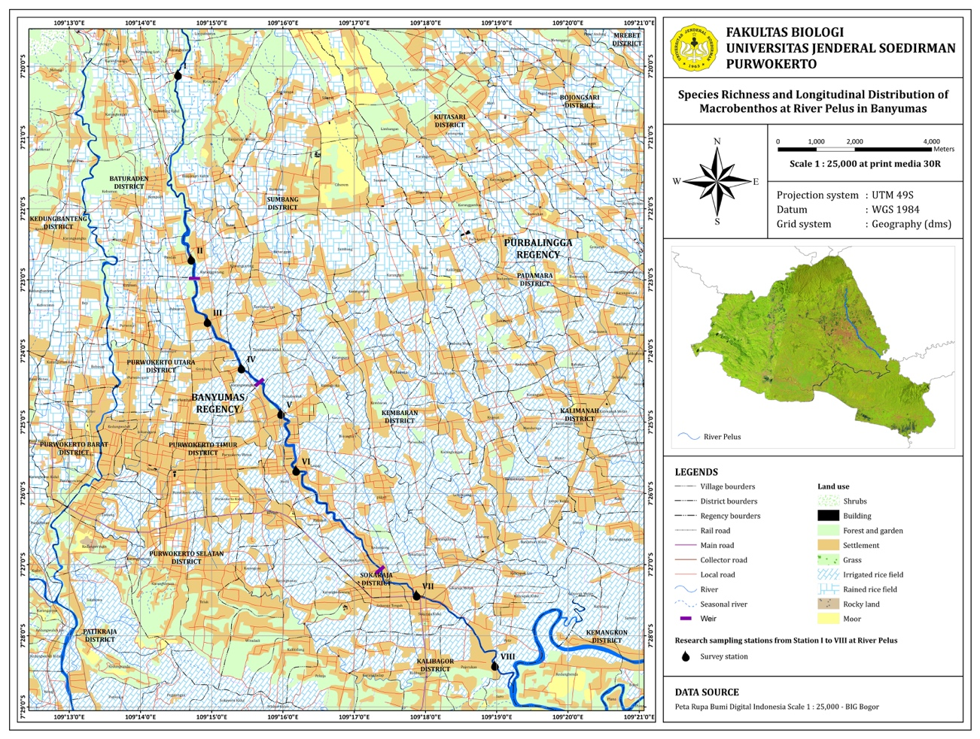

Figure 1. Research sampling stations from Station I to VIII along River Pelus

The conditions of each station vary based on their coordinate, altitude, riverside, substrate types, width, and depth in their location (Table 1). There were some river weirs between Station II and III (the Pandak River Weir), between Station IV and V (the Kembaran River Weir), and between Station VI and VII (the Sokaraja River Weir).

Table 1. Condition along River Pelus

|  |  |  |  |  |  |  |  |  |
| --- | --- | --- | --- | --- | --- | --- | --- | --- |
| Condition | Station I | Station II | Station III | Station IV | Station V | Station VI | Station VII | Station VIII |
| Coordinate | 7°20’06.74” S  109°14’31.64” E | 7°22’42.48” S  109°14’42.82” E | 7°23’35.04” S  109°14’56.44” E | 7°24’14.14” S  109°15’25.05” E | 7°24’52.51” S  109°15’58.33” E | 7°25’40.35” S  109°16’11.17” E | 7°27’25.53” S  109°17’52.63” E | 7°28’24.75” S 109°18’58.50” E |
| Altitude | 415 m a.s.l. | 196 m a.s.l. | 157 m a.s.l. | 112 m a.s.l. | 84 m a.s.l. | 67 m a.s.l. | 43 m a.s.l. | 28 m a.s.l. |
| Riverside | forest and gardens | garden and natural bamboos | gardens | restaurant and settlements | restaurant and settlements | restaurant and settlements | settlements | settlement and gardens |
| Substrate types | bedrock (90%), cobble (5%) and gravel (5%) | boulder (50%), cobble (30%) and gravel (20%) | boulder (50%), cobble (30%), gravel (15%) and sand (5%) | boulder (50%), cobble (25%), gravel (15%), sand (5%) and silt (5%) | boulder (10%), cobble (15%), gravel (30%), sand (40%) and silt (15%) | cobble (15%), gravel (35%), sand (35%) and silt (15%) | cobble (10%), gravel (30%), sand (40%) and silt (20%) | cobble (10%), gravel (40%), sand (30%) and silt (20%) |
| Width | 4.4 m | 31.4 m | 35.8 m | 11.5 m | 12.0 m | 14.4 m | 16.2 m | 16.2 m |
| Depth | 0.4 m | 0.2 m | 0.2 m | 0.2 m | 0.3 m | 0.2 m | 0.2 m | 0.3 m |
| Location | Kutayasa Village, Sumbang District | Pandak Village, Baturaden District | Kedungmalang Village, Sumbang District | Kembaran Village, Kembaran District | Dukuhwaluh Village, Kembaran District | Ledug Village, Kembaran District | Sokaraja Tengah Village, Sokaraja District | Suro Village, Kalibagor District |

Macrobenthos, substrate and water samples of River Pelus were taken by Surber net, photoshoot and water sampler, respectively. Surber net, 40x40 cm2, was placed on riverbed and macrobenthos was taken three times in each station with 20 minutes in interval sampling. It was preserved by alcohol 70% inside bottle sampler and put inside iceboxin 4oC*.* For identification and determination [9,12,13], books were used in the Laboratory of Aquatic Biology, Faculty of Biology, Jenderal Soedirman University, Purwokerto. Then, it was verified in the Zoology Department, Research Center of Biology – LIPI, Bogor. Water quality was tested using standard methods for the examination of water and wastewater [14].

* 1. *Data analysis*

After finishing identification and determination, species richness and longitudinal distribution were analyzed by descriptive and distribution patterns in time series.

1. Results

Ten species of macrobenthos consisting of Class Malacostraca and Gastropoda caught by a Surber net. Malacostraca consisted of four species such as two shrimps of *Macrobrachium oenone* and *M. pilimanus*, two crabs of *Parathelpusa bogoriensis* and *P. convexa*; whereas Gastropoda was six species such as six snails of *Lymnaea rubiginosa*, *Filopaludina javanica*, *Melanoides riquerti*, *M. tuberculata*, *Pomacea canaliculata,* and *Sulcospira testidinaria.* Each species calculated in a unit of individual/40x40 cm2 (ind) as average (Table 2).

Table 2. Macrobenthos along River Pelus

|  |  |  |  |  |  |  |  |  |  |
| --- | --- | --- | --- | --- | --- | --- | --- | --- | --- |
| Macrobenthos species | Unit | I | II | III | IV | V | VI | VII | VIII |
| *M. oenone* | ind. |  | 0.2 |  |  |  |  |  |  |
| *M. pilimanus* | ind. | 2.0 | 3.2 | 6.2 | 5.0 |  | 5.0 | 8.0 | 2.8 |
| *P. bogoriensis* | ind. | 1.6 | 4.2 | 1.8 | 3.0 |  | 3.4 | 2.8 | 2.0 |
| *P. convexa* | ind. | 1.0 | 5.0 | 6.0 | 8.8 |  | 6.8 | 5.0 | 4.4 |
| *F. javanica* | ind. | 0.8 | 0.2 |  | 0.2 |  | 2.0 |  | 0.4 |
| *L. rubiginosa* | ind. | 38.0 |  |  | 18.8 |  |  |  |  |
| *M. riquerti* | ind. | 0.6 | 2.2 | 7.0 | 12.8 | 4.2 | 24.4 | 53.2 | 6.6 |
| *M. tuberculata* | ind. |  | 0.6 |  | 0.4 |  | 0.6 |  |  |
| *P. canaliculata* | ind. |  |  | 0.2 | 3.0 | 1.4 | 0.4 |  |  |
| *S. testidinaria* | ind. |  | 14.6 | 12.2 | 2.4 |  | 3.4 | 3.2 | 27.4 |

Six types of substrate consisted of bedrock, boulder, cobble, gravel, sand, and silt. It had tended to decrease in size from Station I to VIII at River Pelus.

Ten variables of water quality consisted of transparency, current velocity, flow velocity, temperature, DO, BOD5, COD, and pH. It had tended to be a good water quality in station II and an inadequate water quality in Station V (Table 3).

Table 3. Water quality along River Pelus

|  |  |  |  |  |  |  |  |  |  |
| --- | --- | --- | --- | --- | --- | --- | --- | --- | --- |
| Water quality variable | Unit | I | II | III | IV | V | VI | VII | VIII |
| Transparency | m | 0.4 | 0.2 | 0.2 | 0.2 | 0.3 | 0.2 | 0.2 | 0.3 |
| Current Velocity | m/s | 0.2 | 0.2 | 0.1 | 0.8 | 0.03 | 0.1 | 0.3 | 0.7 |
| Flow Velocity | m3/s | 0.3 | 1.6 | 1.0 | 1.7 | 0.1 | 0.3 | 1.1 | 3.6 |
| Temperature | oC | 22.6 | 24.4 | 25.0 | 26.2 | 27.8 | 28.0 | 28.2 | 28.2 |
| DO | mg/l | 9.2 | 9.1 | 8.8 | 8.7 | 6.9 | 7.2 | 8.5 | 8.7 |
| BOD5 | mg/l | 1.2 | 1.8 | 2.1 | 2.3 | 2.3 | 2.6 | 17.8 | 24.6 |
| COD | mg/l | 18.0 | 29.0 | 40.5 | 118.0 | 151.5 | 156.5 | 150.0 | 180.0 |
| pH |  | 7 | 7 | 7 | 7 | 6 | 6.5 | 6.5 | 7 |

1. Discussion

There was a unique tendency of decreasing species richness number due to the river weir between Station II (8 species) and III (6 species), IV (9 species) and V (2 species), and VI (8 species) and VII (5 species); whereas there were a tendency of increasing species richness number from Station I (6 species) to II (8 species), from III (6 species) to IV (9 species), from V (2 species) to VI (8 species), and from VII (5 species) to VIII (6 species) (Figure 2a). River weir was as a barrier for nekton longitudinal distribution and should be installed a fishway for their migrations in a good river biodiversity management [15]. The weir is as a barrier for a species longitudinal or spatial distribution and can inhibit species conservation efforts [16]. It means that the river weir can also serve as a barrier for macrobenthos longitudinal distribution at River Pelus.

A river has a zone with high and low species richness of aquatic organism [17]. In Class Malacostraca of River Pelus, Station II was as the zone with high species richness (4 species), whereas other stations were as the zone with low species richness (3 species), except station V (Table 2). One unique species of Class Malacostraca, *M. oenone*, could be categorized as a suitable indicator species because this species only lived in the last of replicates in Station II as much 0.2±0.5 individual/40x40 cm2 in average as the rare species (Figure 3a). The rare species depended on a narrow geographic distribution, a restricted habitat specificity and everywhere small in local population size [18]. In this station, there were substrate types of the boulder (50%), cobble (30%, and gravel (20%) (Figure 2b). This river has the same tendency of substrate types at River Banjaran [19,20]. This class needs boulders for protecting a high velocity [21]. Moreover, it has a good water quality (Table 3) due to the Government Regulation of the Republic of Indonesia Number 82 in the Year of 2001 about water quality management and pollution control for class three [22]. This station was as a suitable habitat for macrobenthos, whereas station V was a bad habitat. In station II, the excellent water quality based on all well below the level considered to be dangerous such as the high current velocity (0.2 m/s) and flow velocity (1.6 m3/s). Moreover, also, the low concentration of BOD5 (1.8 mg/l) and COD (29 mg/l) was causing the high concentration of DO (9.1 mg/l) and pH (7) in the water samples analyzed. In the riverside of this station, there were a garden and natural bamboos. Moreover, there were substrate types of the boulder (50%), cobble (30%) and gravel (20%) (Figure 2b) as the excellent habitat of macrobenthos in lotic waters causing the high species richness (8 species).

In the same class, *M. pilimanus, P. bogoriensis,* and *P. convexa* were in all stations, except station V (Table 2). In the Station II, there were substrate types of the boulder (10%), cobble (15%), gravel (30%), sand (40%), and silt (15%) (Figure 2b); and an inadequate water quality (Table 3) based on the same regulation. In this station, no species found (Table 2) as mentioned by [23] that shrimp could not live in the lowest velocity. In station V, the bad water quality was based on the lowest current velocity (0.03 m/s) and flowed velocity (0.1 m3/s). Moreover, also, the high concentration of BOD5 (2.3 mg/l) and COD (151.5 mg/l) was causing the lowest concentration of DO (6.9 mg/l) and pH (6) in the water samples analyzed (Table 3). Ordo Decapoda could not live in the lowest velocity [24]. In the riverside of this station, there were restaurant and settlements. Moreover, there were substrate types of the boulder (10%), cobble (15%), gravel (30%), sand (40%) and silt (15%) (Figure 2b) as the bad habitat of macrobenthos in lotic waters causing the lowest species richness (2 species).

One unique species of Class Gastropoda, *M. riquerti*, could be categorized as a cosmopolitan species in Station I (0.6 individual), Station II (2.2 individual), Station III (7.0 individual), Station IV (12.8 individual), Station V (4.2 individual), Station VI (24.4 individual), Station VII (53.2 individual) and Station VIII (6.6 individual) in average (Figure 3b) because this species lived in all stations with all substrates and water quality (Table 2). *M. riquerti* could also found in Cilacap [25], Tangerang [26], Jember, Pasuruan, and Malang [27].

|  |  |
| --- | --- |
| (a) |  |

Figure 2. Macrobenthos species richness and longitudinal distribution (a) and substrate (b) along

River Pelus with the river weir between Station II and III, Station IV and V, and Station VI and VII

|  |  |
| --- | --- |
| (a) | (b) |

Figure 3. *M. oenone* (a) and *M. riquerti* (b) along River Pelus with the river weir between

Station II and III, Station IV and V, and Station VI and VII

1. Conclusion

There were ten species of macrobenthos from Class Malacostraca (four species) and Gastropoda (six species). *M. oenone* could be categorized as an indicator and rare species because this species only lived in Station II with the condition of a boulder substrate and good water quality. In the same class, *M. pilimanus, P. bogoriensis,* and *P. convexa* were in all stations, except station V with the condition of a sand substrate and poor water quality. Two species of *M. riquerti* and *P. canaliculata* could live in station V. The first species was as a cosmopolitan species that could live in all substrates and water quality. In the longitudinal distribution map, species richness numbers were decreasing due to the river weir.

References

1. Gaston K J 1996 *Biodiversity: A Biology of Numbers and Difference* (Oxford: Blackwell Science) p 213
2. Al Farisy S, Nugraha W D dan Sutrisno E 2015 *Jurnal Teknik Lingkungan* **4**(4) 108–17
3. Umiatun S, Carmudi dan Christiani 2017 *Scripta Biologica* **4**(1) 61–7
4. Ritonga M I, Nugraha W D dan Sutrisno E 2015 *Jurnal Teknik Lingkungan* **4**(4) [70](http://ejournal-s1.undip.ac.id/index.php/tlingkungan)–8
5. Yuniartiningsih S 2012 *Kajian Dampak Ekologis Kehadiran Ikan yang Diintroduksi terhadap Keragaman Cyprinidae* (Purwokerto: Program Studi S2 Ilmu Biologi, Fakultas Biologi, Universitas Jenderal Soedirman) p 40
6. Lestari W dan Sastranegara M H 2012 *Prosiding Seminar Nasional. Pengembangan Sumber Daya Pedesaan dan Kearifan Lokal Berkelanjutan II (Purwokerto)* vol 2 (Purwokerto: Lembaga Penelitian dan Pengabdian kepada Masyarakat, Universitas Jenderal Soedirman) p 31
7. Ou A C T and Yeo D C J 1995 *Raffles B. Zool*. **43**(2) 299–308
8. Cai Y, Naiyanetr P and Ng P K L 2004 *J. Nat. Hist.* **38** 581–649
9. Ng P K L 2004 Crustacea: Decapoda, Brachyura *Freshwater Invertebrates of the Malaysian Region* ed C M Yule and Y H Sen (Kuala Lumpur: Academy of Sciences Malaysia) chapter 29 p 311–336
10. Chia O K S and Ng P K L 2006 *Raffles B. Zool*. **54** (2) 381–428
11. Wowor D and Short J W 2007 *Raffles B. Zool*. **55**(1) 77–87
12. Darbohoesodo R B 1983 Kunci Determinasi Udang Air Tawar (Purwokerto: Fakultas Biologi, Universitas Jenderal Soedirman) p 20
13. Yule C M 2004 Freshwater Invertebrates *Freshwater Invertebrates of the Malaysian Region* eds C M Yule and Y H Sen (Kuala Lumpur: Academy of Sciences Malaysia) chapter 3 p 23–31
14. APHA, AWWA and WEF 1998 *Water quality were tested using standard methods for examination of water and wastewater* (Washington: APHA, AWWA and WEF)
15. Jansen W, Kappus B, Böhmer J and Beiter T 1999 *Limnologica* **29** 425–35
16. Rolls R J 2010 *Biol. Conserv.* **144** 339–49
17. Maurakis E G, Whitschey R T, Economidis P S and Bobori D 2003 *Virginia Journal of Science* **54**(3) 139–49
18. Magurran A E 1988 *Ecological Diversity and its Measurement* (New Jersey: Princeton University Press) p 112
19. Kusbiyanto 2005 *Analisis Daya Dukung Perairan Sungai Banjaran dalam Upaya Konservasi Udang Macrobrachium spp. di Kabupaten Banyumas* (Purwokerto: Program Studi S2 Ilmu Lingkungan, Program Pascasarjana, Universitas Jenderal Soedirman) p 47
20. Winarni E T 2009 *Komunitas udang Macrobrachium di Sungai Banjaran Kabupaten Banyumas* (Purwokerto: Program Studi S2 Ilmu Biologi, Fakultas Biologi, Universitas Jenderal Soedirman) p 25
21. Cumberlidge N 2009 Freshwater crabs and shrimps (Crustacea: Decapoda) of the Nile Basin *The Nile: Origin, Environments, Limnology and Human Use* ed H J Dumont (Marquette: Department of Biology, Northern Michigan University) chapter 27 pp 547–61
22. Soekarnoputri M 2001 *Peraturan Pemerintah Republik Indonesia Nomor 82 Tahun 2001 tentang pengelolaan kualitas air dan pengendalian pencemaran air* (Jakarta: Deputi Sekretaris Kabinet Bidang Hukum dan Perudangan-undangan) p 297
23. Saito H, Yamasaki A, Watanabe J and Kawai K 2016 *BioInvasions Records* **5**(2) 93–100
24. Fryer G 1980 *Freshwater Biol.* **10**(1) 41–5
25. Firmansyah N, Ihsan Y N and Yuliadi L P 2016 *Jurnal Perikanan Kelautan* **7**(2) 45–50
26. Alfin E 2014 *Al-Kauniyah* **7**(2) 69–73
27. Wimbaningrum R, Indriyani S, Retnaningdyah C and Arisoesilaningsih 2016 *J. Ind. Tour. Dev. Std.* **4**(2) 81–90