**EXTRACTING GENOMIC DNA OF FOSSILISED POLLENSFROM VOLCANOIC SOIL SEDIMENT OF LIYANGAN SITE-CENTRAL JAVA**

**N D SASONGKO¹), WINDRIYANI1),SISWANTO2), S AZIZ1).**

1Faculty of Biology-The University of Jenderal Soedirman, Indoesia

2National Archaeological Agency-Yogyakarta

E-mail: nurtjahjo.sasongko@yahoo.com

**Abstract**. Liyangan buries some artefacts in volcanoic sediment including pollens. Reconstructing ancient plants diversity requires good quality in adequate amount of genomic DNA from fossilised pollens. Current study was aimed to separate pollens from their sediment and extract the pollens. Separation was done according to different protocols (BALAR’s and Geology’s), DNAs were extracted by applying modified-CTAB and mini *Genomic DNA Mini Kit*. Current data showed the two separation and extraction protocols were able to separate fossilized pollens and so extracting them. The BALAR method combined with CTAB resulted in 314µg/ml to 887µg/ml while lower amount of 382µg/ml to 852µg/ml were obtained when extracted by *DNA Mini Kit*. The Geology protocol combined with CTAB resulted even a lower concentrations (43µg/ml to 230µg/ml); and 22 µg/ml to 216 µg/ml by *DNA Mini Kit*. The BALAR’s protocol performed a better result inseparating fossilised pollens from other material. Both extraction methods resulted in adequate amount of genomic DNA though in quite low quality.

**Key words: L**iyangan, CTAB, DNA mini kit

1. Introduction

Pollens, male reproductive organs of Angiospermae and Gymnospermae and produced by microsporocyte following meiotic [1]. Pollens might undergo fossilization due to its outer layer which is composed by sporopolenin [2; 3; 4]. [5] stated fossilised pollens are important material to trace the ancient plant’s diversity.

[6] predicted if the pre historic people relied more on the availability of collective foods and raw material sources from surrounding environement. Reconstructing plants diversity and so their abundance at the pre historic age becomes important step in studying the life style of the people. The Liyangan buries some artefacts of hunting tools made of stones and bones, ceramics, and fossilized-burned woods, rice and pollens; as well as Hinduism temple and artefacts [7; 8].

Identification of fossilised pollens based on their morphological characters could not able to identify their speiesor even genera [9].Molecular analyses might then be applied, [10]; and [11] stated that molecular analysis performs better than morphological characters; more stable and has no environement effect [12] though it requires good quality DNA atadequate concentration [13]. Extracting fossilized pollens need special treatment prior to extraction [14]; however, the success of extracting fossilized pollens is quite low as it is strongly related with the treatment thus very limited data were available so far [15].

Extraction might be done either by CTAB [16]or *DNA extraction Kit* [17;18] following preparation methods of BALAR’s and Geology’s protocols.

1. Methods

2.1. *Research Material*

Current study applied soil sediment obtained from the Liyangan site as the main material and some chemicals (2.3.1., 2.3.2. and 2.3.3).

2.2. R*esearch Design*

The research used a survey method employing purposive sampling desing. The sampling waas performed in 5 different sites within the *my field,* an area where ancient people did their activities. The sediment was taken from the soil, as far as 20 cm from top soil. 20 grams soil sediment was then taken and split into 2 parts, and put in the plastic clip which covered by aluminum foil prior to be brought to laboratories for separation (BALAR and Geology Department). The Liyangan site was divided into five spots (Fig. 1).

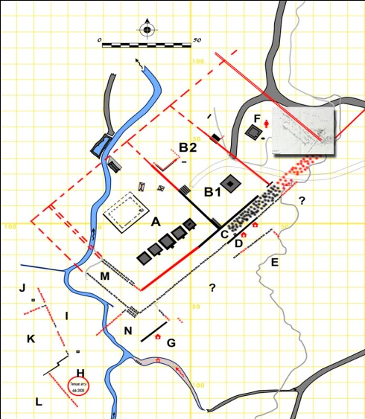

**3**

**4**

**1**

**5**

**1**

**o**

**2**

**3**

**4**

**2**

**1**

**4**

**2**

**1**

Figure 1. Soil sediment sampling sites within the Liyangan

Remark:

Spot 1: Area E: 07o15' 07,4" SL and 110o01'39,3" EL and 1184 m alt.

Spot 2: Area C: 07o15'07,1" SL, 110o,1'38,1" EL and 1186 m alt.

Spot 3: Area M: 07o15'07,7" SL,110o,5" El and 1173 m alt.

Spot 4: Area A: 07o15'07,4" SL,110o01'36,8" EL and 1169 m alt.

Spot 5: Area O: 0 o15'07,9" SL,110o01'36,9" EL and 1152 m alt.

Soil sediment were divided into 2 parts prior to separation from the fossilized pollens according to BALAR and GEOLOGY protocols. The parameter observed from these two protocols was morphological character of fossilized pollens.

2.3. *Research protocols*

2.3.1. *The BALAR’sprotocol*

7 gram of sediment’s powder put into the reaction tube, added 5 ml 30%HCl, left for 10’ and centrifuged at 2,500 rpm for 10’. Add the pellet with 5 ml H2O, done in triplicates. Natant was added with 70% HF, incubated in the dark room for 24 hours, and re-centrifuged and cleaned with H2O four times. The natant was added with 5 ml 30% HCl, heated for 15’ and re-centrifuged, cleansed three times with H2O. Natant was added with 5 ml 30% KOH and heated for 20’, and re-centrifuged, add pellet with 5 ml 30% KOH three times and re-centrifuged. Added natant with 50% HNO3and 30% HCl (100:5), heated for 10’ and re- centrifuged.Add the natant with H2O and re-centrifuged in triplicates.

*2.3.2. The Geology protocol*

7 gram of sediment powder was put into a beaker glass and added with 50% HCl, homogenized and incubated for 3 Hours. Neutralized the natant withH2O to pH (7), sinked in 40% HF, homogenized and incubated for 24 hours. Reneutralized the natant with H2O, add50% HCl, the natant and heated for 2 hours, and neutralized with H2O, sieved sequentially with 150µ and 5µ sieves. Transferred the natant to a tube, added 50% HNO3and heated for 10’, neutralized with 10% KOH, and H2O.

The obtained fossilized pollens were extracted by modified CTAB and genomic DNA extraction kit *PureLink®* then quantified.

2.3.3. *Modified CTAB* [16]*.*

0.5 gram fossilized pollens was grinded, added with 1,500 ml warmed-CTAB buffer and 15 µlβ mercaptoethanol. Transferred the sample into a 1.5 ml microcentrifuge tube, warmed in a water bath at 65oC for 60’ and homogenized, centrifuged at 11,000 rpm for 10’. Trtansfered supernatant into a newtube, added with 800 µl cold CIAA 24:1 (chloroform iso amyl alcohol), vortexed for 5’, and centrifuged at 11,000 rpm for 20’, transferred to a new tube, added with ammonium acetic 1/10 of the supernatant volume, and 2/3 cold absoluteethanol, homogenized and incubated in -20oC over night. The mixture was recentrifuged at 11,000 rpm, 4oC for 20’. Add the pellet with 750 µl 70% Ethanol, centrifuged for 5’ at 11,000 rpm, and placed the tube up side down on a tissue paper.

*2.3.4.Genomic DNA extraction Kit*

0.5 gram fossilized pollens, put into a sterile eppendorf tube and added with 180 µl *PureLink*® Genomic Digestion Buffer plus 20 µl K Proteinase and homogenised. Incubate the mixture in a waterbath at 55⁰C for 2 Hours, and cooled down before centrifuged at 6,000 rpm for 3’. Transferred the supernatant into a new tube, added with 20µl RNase A, vortexed for 10’ and left for 2’ at RT. Add the mixture with 200 µl *PureLink® Genomic Lysis/Binding Buffer*, vortexed, added with 200µl absolute ethanol and re vortexed. Transferred into the *PureLink® Spin Column*tube*,*add with 500 µl *Wash Buffer* 1, centrifuged at 10,000 rpm for 1’, transferred into a new column tube*.*Add the mixture with 500 µl *Wash Buffer* 2, centrifuged for 3’ at 10,000 rpm. Trenasfeer *spin column*into a new tube, add 50 µl *PureLink® Genomic Elution*, left for 1’, centrifuged at 10,000 rpm for 1’, add 50 µl *PureLink® Genomic Elution* before recentrifuged at the same speed and time kept the tube containing DNA and kept at -20 oC.

Parameter observed from this step was DNA extract, which were quantified and scored,andinterpreted for their quality [26] at absorbance ofA260/230nm and A260/230nm as pure, contaminated by carbohydrate, protein or RNA.

3. Results

Both preparation methods, succeeded in separating fossilized pollens from their volcanoic material and gases and visible under microscope (Fig. 2).

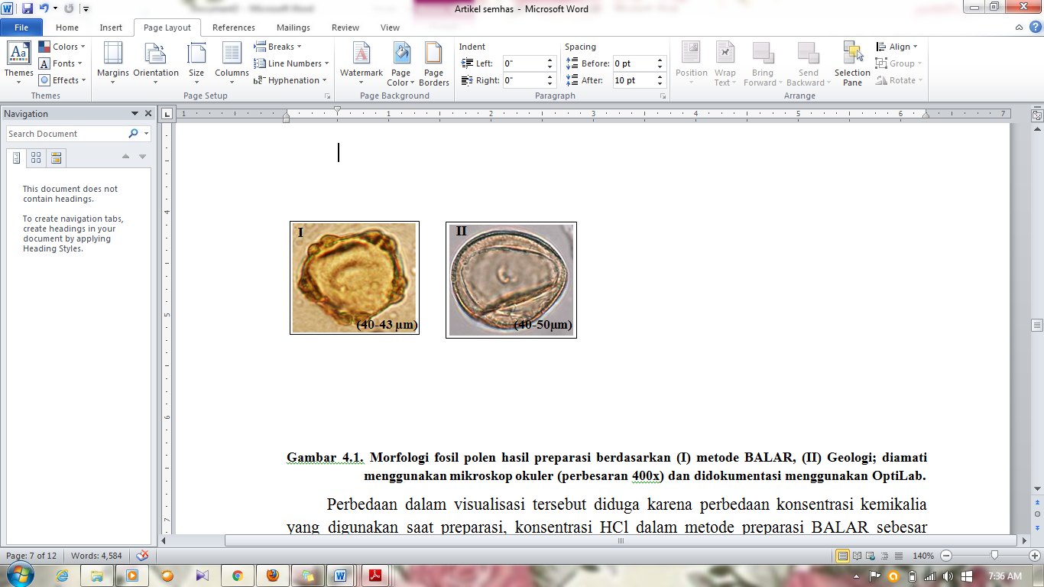

Figure 2. Visualisation of fossilized pollens prepared with (I) the BALAR method, (II) Geologi method (400x) and documented using an opti Lab camera.

Both extraction methods (CTAB and *mini Kit*) also succeeded in extracting the DNA in various amount and purity (Fig. 3). CTAB preceeded by BALAR protocol, resulted in 314µg/ml to 887µg/ml DNA, which was slightly higher than that obtained using another protocol, i.e: 382µg/mlto 852µg/ml. On the other hand, CTAB following Geology protocol obtained much lower amount (43µg/ml to 230µg/ml; and 22 µg/ml to 216 µg/ml).

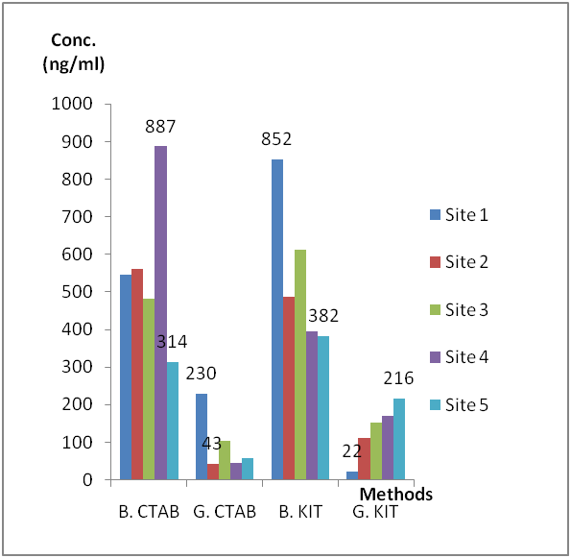

Figure 3. DNA concentration of fossilised pollens applying CTAB and KIT extraction methods following sediment preparation by BALAR and GEOLOGY protocols

The DNA extracted from both methods, however, were contaminated by either carbohydrate, RNA, protein or humic acid (HA) as reflected in its absobrance either <1.8 or >1.8 (Fig. 4-6).

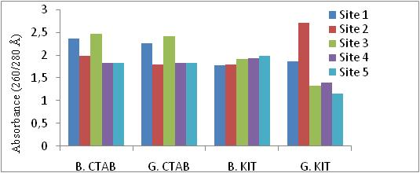

Remarks: B. CTAB and KIT, separated according to BALAR and extracted by the CTAB and DNA *extraction kit*

G. CTAB and KIT, separated according to Geology and extracted by the CTAB and DNA *extraction kit*

Figure 4. The Purity of DNA of fossilised pollens at the ratio of 260/280Å

The extract DNA’s obtained from those separation and extraction were then visualized in agar plate following the PCR

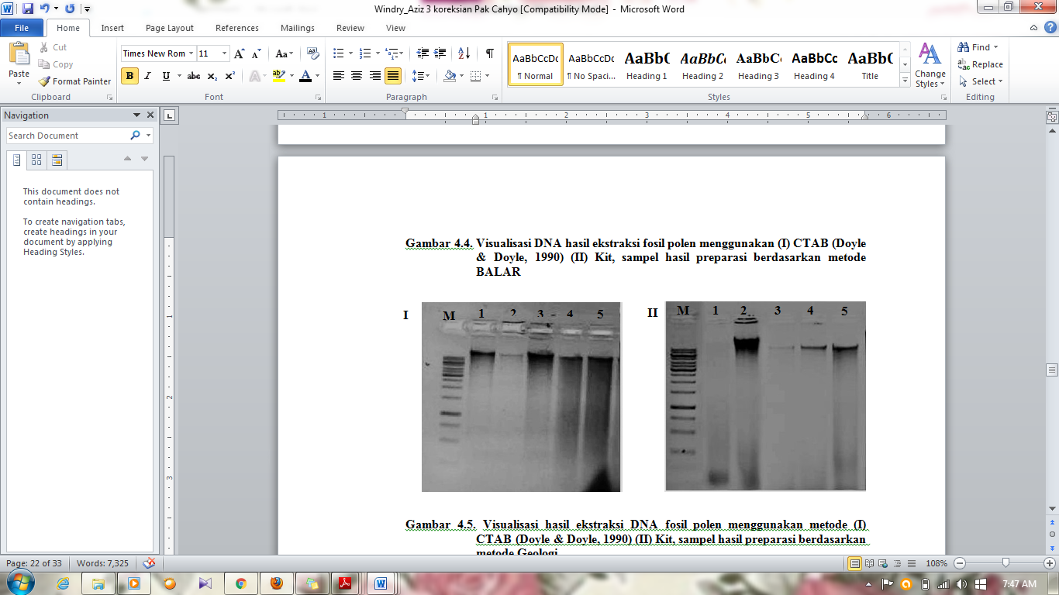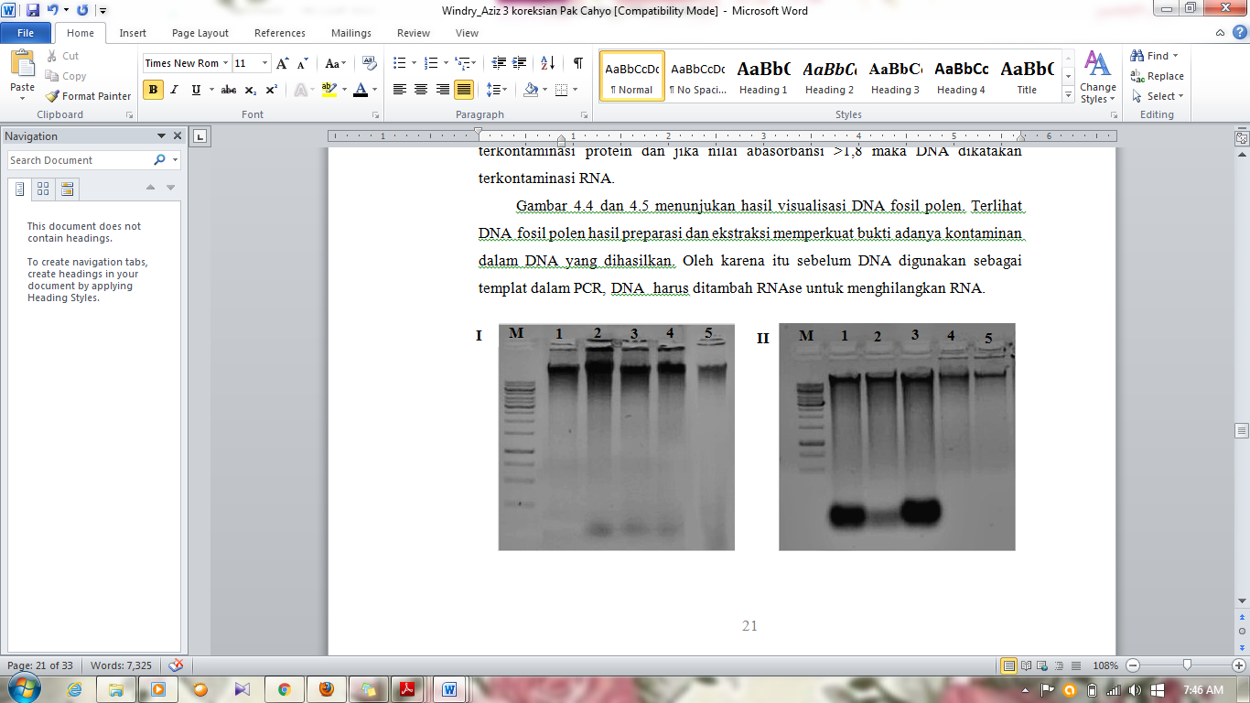

A B

Figure 5. Visualization of Extracted DNA of fossilized pollens (A) BALAR and CTAB (I), *DNA Mini Kit*(II); (B) GEOLOGY and CTAB (I), *DNA mini Kit* (II).

4. Discussion

Discrepancies in the visualization morpholgical fossilized pollens (Fig. 2) might probably due to diferent concentration of HCl applied during separation. The clear vision in Geology protocol was obtained from the use of 50% HCl, in contrast to 30% in BALAR’s. HCl is a strong monoprotic, thus the higher concentration would resukted in the faster release of sediment from pollens [19], but not the gasses like humic acid (HA).

[20]reported volcanoic ashes or sediment contain the HA abundantly as a polielectrolite-organic macro molecule and might interact with metal to form metal HA complex or involving in oxidising processes to form quinon to covalently ties to the DNA[21]. In attempts to minimise it,[22] suggested the use of sodium carbonate to release HA, meanwhile, [23]stated differently.Extraction of the DNA originally obtained from volcanoic sediment material might not to clean up the HA fully thus affecting the quality and quantity of the DNA obtained. For this purpose, [24] suggested the use of PVP in the lysis buffer to lyse the hard outer part of pollen shell.

Current study, unfortunately, did not apply the last two suggestions and so caused the poor quality and quantity of DNA obtained.

Alternatively, the low concentration of extracted DNA obtained might be caused by the volume of KOH, incubation time and homogenisation of the sediment during separation. According to [25] addition of KOH will automatically increase the pH of the solution to 11 and forces to dissolve HA. However, both concentrations of 10% KOH in Geology and 30% in BALAR, did not performed well in dissolving it fully. Another, possibility was centrifugation, where the BALAR protocol includes this step in its protocol while Geology’s does not.

Apart from that[9]reported the very tiny size of fossilized pollens, as well as types, and numbers which lead to low concentrations of extracted DNA in this study. [26] stated that the pollens of *Hibiscus rosa-sinensis* varies from (89.66 um to 112.92 um), thus requires specific precautions and treatment on extracting them fully. The purer the fossilized-pollens the better result of DNA extract obtained. According to [27], current data were classified as contaminated by carbohydrates where the absorbant was <2. In most of the cases,[28]stated that DNA of volcanoic sediment was mainly contaminated by HA.

Apart from the HA, RNA or protein might also contaminated the DNA [28] as noted here, the absorbant score was either <1.8 or >18 at ratio of A260/280(Fig 4.).The slight smear on DNA bands indicated that the current extract DNA were contaminated by such those things, but still possible to be used as material for further analyses [29].

5. Conclusion

Current data concluded that: both separation protocols (BALAR and GEOLOGY) are able to separate fossilized pollens from their vulcanoic sediment. Both extraction methods, are also performed well in extracting DNA of fossilized-pollens. However, some suggestion might also be written to overcome such problems in separation of fossilized-pollens from their volcanoic sediment and gasses and extracting the fossilized-pollens to obtained good quantity and quality DNA for amplification.

**6. Acknowledgement**

We would like to pass our gratitude to the BALAR (ARCHAEOLOGICAL AGENCY) for allowing us entering the excavation site and bringing some soil sediment from the site. We would also thank to the Geology Faculty of the University of Jenderal Soedirman-Purwokerto-Indonesia, for allowing us to compare the sediment’s preparation protocol. The last but not the least, we thank to the Molecular and Genetic Laboratory of Biology Faculty the University of Jenderal Soedirman-Purwokerto-Indonesia for allowing us extracting and analysing the fossilized pollens.

**References**

[1] Campbell, NA, Williamson, B. & Heyden, R.J 2004. *Biology: Exploring Life*. Needham. Pearson-Prentice Hall.

[2] Faergi, K. J. & Ivaersen J 1989. *Textbook of pollen analysis*1st Ed. Harper Publishing Co. Walrhan Mass USA.

[3]Moor, PO., Went and Collin ME 1991. *Pollen Analysis*.Blackwell Scientifc Publication Oxford.

[4] ErdtmanG 1952. *Pollen Morphology and Plant Taxonomy Angiosperms (An Introduction to Palynology I*). The Chronica Co. New York.

[5] Nurani, IA 2016. Teknologi Pembuatan Alat dan Perhiasan Di Gua Kidang, Blora. *Balai Arkeologi D.I. Yogyakarta.* Vol. 36 No. 1.

[6] Abbas, N 2014. *Liyangan Mozaik Peradaban Mataram Kuno di Lereng Sindoro*. Kementerian Pendidikan dan Kebudayaan Balai Arkeologi Yogyakarta. Amara Books

[7] Iqbal, M 2014. Liyangan, Kota Mataram Kuno Terendam Letusan Sindoro. [*http://faktaunik-didunia.blogspot.com/2014/03/liyangan-kota-mataram-kuno-yang.html*. Diakses 8 Maret 2015](http://faktaunik-didunia.blogspot.com/2014/03/liyangan-kota-mataram-kuno-yang.html.%20Diakses%208%20Maret%202015)

[8]Windriyani, Noerwidi S, Dekon S, Siswanto, and N.D. Sasongko 2015. Predicting Ancient Crops Diversityin Liyangan Site.Presented inInternational Conference on Plant Diversity.UNSOED.Purwokerto.

[9] Trimanto, 2010. *Karakterisasi dan Jarak Kemiripan (Dioscorea alata L.) Berdasarkan Penanda Morfologi Umbi*. LIPI. 12 (3), pp. 4-5.

10] Widiastuti A, Sobir, M and Suhartanto, R 2013. Analisis Keragaman Genetik Manggis (*Garcinia mangostana*) diiradiasi dengan Sinar Gamma berdasarkan Penanda ISSR. *Jurnal Bioteknologi*. 10 (1), pp.15-22.

[11] Zulfahmi, R 2013. Penanda DNA untuk Analisis Genetik Tanaman. *Jurnal Agroteknologi*. 24 (8), pp. 32-46.

[12] Fathiyah 2011. Uji Kuantitatif dan Uji Kualitatif dalam Arumingtyas E., L, Widyarti S, Rahayu. *Biologi Molekular*. Prinsip Dasar Analisis. Jakarta: Erlangga.

[13] Suyama YM, Kawamuro K, Kinoshita L and Takahara1996. Inspection of DNA in Fosil Pollen of *Abies* spp. From Late Pleistocene Peat. *Journal Science*. 77 (3), pp. 272-274.

[14] Ye Jian, Anquan JI, J Esteban, Xiufen Zheng, Chengtao Jiang and Xingchun Zhao 2004. A Simple and Efficient Method for Extracting DNA From Old and Burned Bone. *Journal Forensic Science*. 12 (6), pp. 491-497.

[15] Doyle JJ, and JL Doyle1990. Isolation of plant DNA from fresh tissue. *Focus*. Moscow.

[16] Nalini E, N Jawali, and SG Bhagwat 2003. A Simple Method for Isolation of DNA from Plants Suitable for long term storage and DNA Marker Analysis. *Journal Bhabha Atomic Research Center Newsletter*. pp. 208-214.

[17] Mazieda, MN, SK Sari, Listyorini and ES Sulasmi2009. Optimasi Teknik Isolasi dan Purifikasi DNA pada Daun Cabai Rawit (*Capsicum frutescens* cv. Cakra Hijau) Menggunakan CTAB dan Genomic DNA Mini Kit Plant Geneaid. Fakultas Biologi. Universitas Malang. *Jurnal Genetika*. 4 (4), pp. 1-12.

[18] Harrocks, M, SA Coulson, and KAJ Walsh1999. Forensic palinology: variation in the pollen content of soil on shoes and inshoeprints in soil. *Journal Forensic Science*.pp.119–122.

[19] Zhou, J, MA Bruns and JM Tiedje1996. DNA Recovery from Soils of Diverse Composition.*Applied and Environmental Microbiology*. 62(2), pp. 316-322.

[20] Yuliati, YB and CL Natanael2016. Isolasi Karakterisasi T asam humat dan penentuan daya serapnya terhadap ion logam Pb (II), Cu (II) dan Fe (II). 2016. Al-Kimia 4 (1) pp:43-53

[21]Young, CC, RL Burghoff, LG Keim, B Minak and SM Hinton1993. Polyvinyl- pyrrolidone Agarose Gel Electroforesis Purification of Polymerase Chain Reaction Amplifiable DNA from Soil.*Journal Applying Environmental Microbiol*.pp.1971-1974.

[22] Zipper, H, C Buta, K Lammle, J Bernhagen and F Vitzthum2003. Mechanisms Underlying the Impact of Humic Acids on DNA Quantification by SYBR Green I and Consequences for the Analysis of Soil and Aquatic Sediments. *Journal Nucleic Acids*. 31 (7), pp: 31-39.

[23] Rajendhran, J and P Gunasekaran 2008. Strategies for accessing soil metagenome for desired application. Biotechmology Advances. 25(6), pp 576-590.

[24] Fong, SS, L Seng, WN Chong, J Asing, M Faizal and AS Pauzan2006. Characterization of the Coal Derived Humic Acids from Mukah, Sarawak as Soil Conditioner. *Journal Brazilian Chemical Society.* pp. 582-587.

[25] Apriyanti, DNM, and E Kriswiyanti2008. Studi Variasi Ukuran Serbuk sari kembang sepatu(*Hibiscus rosa-sinensis*) dengan warna bunga berbeda. Jurna Biologi. XII (1) 14-18.

[26] Sahasrabudhe, A and M Deodhar2010.Standardization of DNA Extraction and Optimization of RAPD-PCR Conditions in Gracinia indica.*International Journal of Botany*, 6(3). pp. 293-298.

[27]Yeates, C, MR Gillings, AD Davidson, N Altavilla, and DA VealMethods for microbial DNA extraction from soil for PCR amplification 1998.*Biological Procedures Online*. pp. 40-47.

[28] Sambrook, J and DW Russel 1989. *Molecular Cloning: A Laboratory Manual*. New York: Cold-Spring Harbor Laboratory Press.

[29] Syafaruddin and TJ Santoso2011. Optimasi Teknik Isolasi dan Purifikasi DNA yang Efisien dan Efektif pada Kemiri Sunan (*Reutalis trisperma* (Blanco) Airy Shaw).*Jurnal Littri.* 17(1), pp. 11-17.