**MANGROVE FLORA IN TOMINI BAY - INDONESIA**

Rignolda Djamaluddin, Marine Science Study Program, Faculty of Fisheries and Marine Science, Sam Ratulangi University, Kampus Bahu Manado 5115, Email: rignolda@gmail.com

**Abstract**

Mangroves in Tominy Bay are of ecological importance. They occur in the specific environment close to the equator. In the absent of mangrove floristic information, a long term observation had been conducted to investigate mangrove species composition in relation to habitat conditions. In this observation, 159 locations in the Bay were visited and all presence mangrove floras were identified. A total of 27 species were recorded and they distributed over ten types of habitat or environmental units. *Avicennia marina, Bruguiera gymnorrhiza, Rhizophora apiculata* seem to be common species, and have ability to adapt to different environmental conditions. Other species growing on specific habitat conditions such as *Pempis acidula* and *Bruguiera cylindrica* are assumed to continue their new establishment. But, an isolated population of *Osbornia octodonta* in Panua Nature Reserve is expected to experience problem of survival.

Keywords: Tomini Bay, equator, *Osbornia octodonta*

**Introduction**

Mangrove is of valuable coastal resources in Tomini Bay. Its presence supports the high productivity of adjacent coastal environments and protects the coastal lines from actions of oceanography factors. This coastal forest ecosystem covers almost entire coastal environment of the Bay, between latitude 1.5o S and 0.6o N, longitude 120o and 125o E. It is, of course, a unique mangrove ecosystems growing close to the equator condition. Interpretation to satellite image 2009 – 2010 indicated that the total area of mangrove in the Bay is of some 16,105.40 hectares. Some 6,307.85 hectares is located along the coast of Parigi Moutong District in the Province of Central Sulawesi, some 8,872.53 hectares in the Province of Gorontalo, and the remaining 925.02 hectares in the North Sulawesi Province. Mangroves of the Bay have experienced serious problem due to conversion the ecosystems into shrimp pond (locally call *tambak*). During the last two decades, the Bay has lost 10,787.55 hectares of this ecosystem (Damanik and Djamaluddin, 2012).

Information of mangrove species inhabited coastal environments within Tomini Bay is not available until a big mangrove survey supported by IUCN in supporting Susclam (Sustainable Coastal Livelihoods and Management) Program was completed in 2011. Using the record of Tomlinson (1986) for biogeographical region between 120o E and 135o E, there may be a total 32 species in the Bay. In comparison, the updated record by Duke *et al*. (1998), which include Tomini Bay and the larger biogeographical region of Indo-Malesia, describes a total of 51 species including putative hybrids.

Mangroves are known to occupy well-defined zones dominated by a single species or a group of similar species, in parallel zones along the shoreline, or along margins of estuaries (Chapman, 1976). But the pattern in the field are often more complex and unpredictable (Bunt, 1996). Where mangrove communities are zoned, their distribution are often related to variation in substrate characteristics, or sediment elevation with respect to duration of tidal submergence, or prevailing climatic condition; including fluctuating rainfall. Various types of coastal habitats in Tomini Bay may facilitate typical species of mangrove to grow.

This study reports on an investigation of the diversity and identity of mangrove within the Bay. Field investigations have been conducted since the last five years to collect mangrove species from any locations in the Bay from the far point in Bolaang Mongondow Selatan District to Parigi Moutong District covering an approximately 1,000 km long. Types of habitat of any particular mangrove species were also described in term of substrate characteristics, duration of tidal submergence, freshwater influence and range of salinity for particular circumstances.

**Materials and Methods**

A total 159 locations were visited to investigate mangrove species presence. Field determination of the flora were confirmed by reference to arrange of systematic reviews e.g. van Stennis (1955-58), Ding hou (1958), Percival and Womersley (1975), Chapman (1975), Blasco (1984), Fernado and Pancho (1980), Tomlinson (1986), Duke (1991), and Mabberley *et al*. (1995). The specimens used for the determination of the flora were also photographed. Any aspects in relation to topography and tidal inundation, nature of soil, freshwater influences and salinity level were used to describe environmental units or habitats.

**Result and Discussion**

A total 159 locations along the coast between Lobang Kabo (00 o 26,498’ N; 124 o 21,560’ E) at Bolaang Mongondow Selatan District and location of Tanjung Bendera at Sausu Piore (00 o 59’48,3” N; 120 o 30’ 10,0 E) at Parigi Moutong District have been visited. It is predicted that almost all habitat types of mangrove in the Bay were observed and this suggests that more or less all mangrove species presence was probably investigated.

**Mangrove flora and their local distribution**

The mangrove flora in Tomini Bay comprises of at least 27 species. Table 1 represents all species recorded in the Bay, including their local name. It is important to note that for the majority of these species there was a local name, indicating that mangrove identities are acknowledged by local communities, and we can therefore presume a considerable degree of local knowledge. While there is a remarkable coincidence of local name with formal scientific names this does not always occur. Some local names were applied to two or more taxa, likewise there was apparently no local name for a number of species.

**Tabel 1**. Saintific and local names of mangrove in Tomini Bay.

|  |  |  |
| --- | --- | --- |
| **Famili** | **Spesis** | **Local name** |
| Achanthacea | *Achantus ilicifolius* | *Kakata* (Bajo name; meaning crawling plant)  *Kantu-kantu* |
| Avicenniacea | *Avicennia lanata* | *Ngea* (Bajo name; meaning strong) |
| *Avicennia marina* | *Murite* (Bajo name; meaning making sound when burning or stepping)  *Yapi-yapi* (……..name; meaning pleated) |
| Cobretaceae | *Lumnitzera littorea* |  |
| *Lumnitzera racemosaa* |  |
| Euphorbiaceae | *Excoecaria agallocha* |  |
| Lythraceae | *Pempis acidula* | Santigi  Ngihade (Sangir name) |
| Meliaceae | *Xylocarpus granatum* | Tatambu (Bajo name)  Andai (Gorontalo name) |
| *Xylocarpus moluccensis* |  |
| Myrcinaceae | *Aegiceras corniculatum* |  |
| 1. *Aegiceras floridum* |  |
| Myrtaceae | *Osbornia octodonta\** |  |
| Palmae | *Nypa fruticans* | *Tuho* (Bajo name)  *Lipa* (Gorontalo name; meaning easy to fold)  *Nifa* |
| Pteridacea | *Acrosticum aureum* | *Dudu* |
|  | *Acrosticum speciosum* |  |
| Rhizophoraceae | *Bruguiera cylindrical\** |  |
| *Bruguiera gymnorrhiza* | *Munto lila* (Bajo name)  *Tangalo boise* (Gorontalo name)  *Bintu mabfu, lolaro babi* |
| *Bruguiera parviflora* | Munto dinda (Bajo name) |
| *Ceriops tagal* | *Tingar* (Bajo name)  *Tangalo tutu* (Gorontalo name)  *Tangere* |
| *Rhizophora apiculata* | *Bangkau dinda* (Bajo)  *Tangalo wuata, Tangalo tangedi* (Gorontalo name; meaning foot or hanging)  *Bintu* |
| *Rhizophora mucronata* | *Bangkau lila* (Bajo name)  *Tangalo wuata* (Gorontalo name)  *Bintu ngarasi* |
| *Rhyzophora stylosa* | Tangalo wuata (Gorontalo name) |
| Rubiaceae | *Scyphyphora hydrophyllacea* |  |
| Sonneratiaceae | *Sonneratia alba* | *Papa dinda* (Bajo name)  *Tangalo tamendaa* (Gorontalo name)  *Popa buya* |
| *Sonneratia caseolaris* | *Popa fa* |
| Sterculiaceae | *Heritiera globulus* | *Tumpeng laut* |
| *Heritiera littoralis* |  |

*) uncommon/restricted distribution species, discussed separately in the next section

In comparing to mangrove flora in the north coast of northern tip of Sulawesi Island as such in Bunaken National Park (1o 35’ 41” and 1 o 16’ 44” N; 124 o 32’ 22” and 124 o 50’ 50” E), the mangrove species composition in Tomini Bay is of difference to some extent. Using the record by Davie *et al*. (1996) and Djamaluddin (2004) for the mangrove flora in Bunaken Nasional Park, four species of *Avicennia alba, Camptostemon phhilippensis, Bruguiera sexangula,* and *Sonneratia ovata* do not occur in Tomini Bay. Meanwhile, species of *Osbornia octodonta, Pempis acidula and Heritiera globulus* seemto be typical species of Tomini Bay. Different environmental gradients or habitats cause varying physiological responses in different species. There will, according to Thom (1982), be more or less favorable plant growth in a specific habitat due to the response of species to stress conditions. Tomlinson (1986) listed the total of 32 species for the broader longitudinal biogeographic region between 120o and 135o E (including Sulawesi), comparing to 27 species in Tomini Bay.

In general, geomorphological processes of the coastal environments of the Bay are influencing much by the relative orientation/position of any certain coastal environments to the Bay’s morphological position. Outer the mouth of the Bay, coastal environments are more open and under influence by seasonally south and west winds that usually create big wave and generate active coastal currents. This situation supports the formation of reasonably narrow and steep littoral zone with hard substrate type in common and cliff form at any certain locations. Under this situation mangrove ecosystems develop on constricted intertidal zone with hard and shallow substrate. Inner side of the mouth of the Bay, geomorphological processes of the coastal environments is controlled primarily by east wind that supports the formation of quite strike coastal line and sedimentation westward. Shallow and flat topography of littoral zone then contributes to the formation of broad intertidal zone where mangrove ecosystems develop. Due to massive supply of sediments from several rivers, intertidal zone in this area is subjected to sedimentation. Physical oceanography factors in particular wave and coastal currents within the Bay are influenced greatly by local winds, so that energy to create wave and coastal current is relatively powerless. This condition of physical oceanography in combination with moderately flat coastal topography results in the formation of broad intertidal zone which are subjected to sedimentation. Mangrove ecosystems are growing on habitats characterizing by deep substrate and physically unstable.

Coastal geomorphological diversity correlates with local mangrove distribution (Thom, 1967 and 1982). Within its 16,105.40 hectares area of mangroves there are a number of habitat conditions where mangrove species grow, and it is clear that identity and diversity of mangroves varies with habitat conditions. Using physiographic factors proposed by Clarke and Hannon (1969) and Balanchandra (1988), identifying patterns in tidal flooding, salinity, soil condition, water table and seepage, and classification of mangrove habitats applied for Bunaken National Park (Djamaluddin, 2004), there are at least ten habitat types of mangroves in Tomini Bay, as follows: (1) Estuarine: characterized by a fine and deep clay sediment, poorly drained, frequently waterlodgged, and inundated by seawater only at high spring, (2)Seaward fringe: characterized by sand sediment with small proportion of fine sediments, occurs along the seaward and inundated all the time, (3) Coralline sand berm: an island habitat characterised by coralline sand berm, inundated by seawater at almost all tide levels, (4) Seaward young soil: subjected to accumulation of fine sediments (mostly non-organic) from the tidal channel mouth, inundated at all tide levels, (5) Very stable and flat middle zone: characterised by organic sediment, less steep topography, inundated by tidal water at normal high tide, and often stable, (6) Tidal stream edge: occurs along tidal-stream edge, substrate types and inundation levels far from homogenous, to some extents can be divided into prograding and eroding banks, down, middle and upper streams, (7) Less steep and eroding landward: characterized by saline to very saline due to diminishing of tidal inundation and high evaporation, normally inundated by tidal water up to four times a month, shallow substrate and in many cases excessively eroded, (8) Highly accreting inland fringe: characterized by not smooth substrate surface with many mounds that are never inundated, substrate surface raised to a level that can only be reached by tidal water at maximum high spring tide, (9) Seasonally or regularly freshwater influenced: another type of landward fringe habitat characterised by the influence freshwater primarily from seasonal rainwater or freshwater source in the vicinity, inundated several times a month by tidal water, (10) Seaward beach: characterized by fine to coarse sand sediments and remains dry at all tidal level.

Tabel 2 shows mangrove species distribution patterns within the various types of habitat in Tomini Bay. This table also shows differences in the species composition and diversity for each habitat. In general it can be said that the 10 habitats all have different species composition and diversity. In other word, any differences in species composition and diversity are also an expression of the ability adaptation of species to persist in habitats, and this is further reflected in their spatial distribution pattern. As can be seen in this table, three species of *Avicennia marina, Bruguiera gymnorrhiza* and *Rhizophora apiculata* occur in almost all habitat types, indicating that they are very common species. Other species may occur at specific habitat but they are in big population such as *Ceriops tagal, Pempis acidula, Sonneratia alba* and *Schyphiphora hydrophyllacea*. Meanwhile, three species of *Bruguiera cylindrica*, *Osbornia octodonta, and Heritiera globulus* occur only at specific habitats in small population size.

**Tabel 2**. Mangrove species within ten habitat types.

|  |  |  |  |  |  |  |  |  |  |  |  |
| --- | --- | --- | --- | --- | --- | --- | --- | --- | --- | --- | --- |
| **No.** | **Species** | **Types of Habitat** | | | | | | | | | |
| **1** | **2** | **3** | **4** | **5** | **6** | **7** | **8** | **9** | **10** |
| 1. | *Acanthus ilicifolius* | √ |  |  |  |  |  |  | √ | √ |  |
| 2. | *Acrosticum aureum* | √ |  |  |  |  |  |  | √ | √ |  |
| 3. | *Acrosticum speciosum* | √ |  |  |  |  |  |  | √ | √ |  |
| 4. | *Aegiceras corniculatum* |  |  |  |  |  | √ | √ |  |  |  |
| 5. | *Aegiceras floridum* |  |  | √ |  |  |  |  |  |  |  |
| 6. | *Avicennia lanata* |  |  |  |  |  |  |  | √ |  |  |
| 7. | *Avicennia marina* |  | √ | √ | √ |  | √ | √ | √ | √ |  |
| 8. | *Bruguiera cylindrica* |  |  |  |  |  |  |  | √ | √ |  |
| 9. | *Bruguiera gymnorrhiza* |  |  | √ |  | √ | √ | √ | √ | √ |  |
| 10. | *Bruguiera parviflora* |  |  |  |  |  |  |  |  |  |  |
| 11. | *Ceriops tagal* |  |  |  |  | √ |  | √ | √ |  |  |
| 12. | *Excoecaria agallocha* | √ |  |  |  |  |  |  | √ | √ |  |
| 13. | *Heritiera globules* |  |  |  |  |  |  |  | √ |  |  |
| 14. | *Heritiera littoralis* |  |  |  |  |  |  |  | √ |  |  |
| 15. | *Lumnitzera littorea* |  |  |  |  |  |  | √ |  |  |  |
| 16. | *Lumnitzera racemosa* | √ |  |  |  |  |  |  |  | √ |  |
| 17. | *Nypa fruticans* | √ |  |  |  |  |  |  |  | √ |  |
| 18. | *Osbornia octodonta* |  |  |  |  |  |  |  |  | √ |  |
| 19. | *Pempis acidula* |  |  |  |  |  |  |  |  |  | √ |
| 20. | *Rhizophora apiculata* | √ | √ | √ | √ | √ | √ | √ | √ | √ |  |
| 21. | *Rhizophora mucronata* |  | √ |  |  | √ |  |  |  |  |  |
| 22. | *Rhizophora stylosa* |  | √ |  |  | √ |  |  |  |  |  |
| 23. | *Scyphiphora hydrophyllacea* |  |  |  |  |  |  | √ |  |  |  |
| 24. | *Sonneratia alba* |  | √ | √ | √ |  |  |  |  |  |  |
| 25. | *Sonneratia caseolaris* | √ |  |  |  |  | √ |  | √ |  |  |
| 26. | *Xylocarpus granatum* |  |  |  |  |  | √ | √ | √ |  |  |
| 27. | *Xylocarpus mekongensis* |  |  |  |  |  | √ | √ | √ |  |  |

Note: Types of habitat: 1) Estuarine, 2) Seaward fringe, 3) Coralline sand berm, 4) Seaward young soil, 5) Very stable and flat middle zone, 6) Tidal stream edge, 7) Less steep and eroding landward, 8) Highly accreting inland fringe, 9) Seasonally or regularly freshwater influenced, 10) Seaward beach.

**Uncommon Species of *Osbornia octodonta* and *Bruguiera cylindrica***

An apparent discontinuity in the distribution of *Osbornia octodonta* in the Philippines, Sulawesi, North Borneo, eastern Java, north Queensland and adjacent Papua New Guinea is indicated in the distribution map by van Steenis (1936). So, the discovery of this plant in a small specific location within Panua Nature Reserve (Cagar Alam Panua) in Pohuwato District is not a big surprise. However, this invention can be scientifically important since reports of this species are not available.

In general, habitat where this species found seems to be typical. Physically, the habitat is like a pond that is inundated by seawater at spring tide, remaining inundated at low tide, and frequently influence by freshwater. It is predicted that the habitat has a wide range of salinity, and trees of this species can only grow at the more elevated edge side of the pond with a shallow substrate dominated by fine sand sediment. Trees of *Ceriops tagal* are found to share the same habitat, but they are not in dense population as usual. Figure 1 shows the habitat condition described.

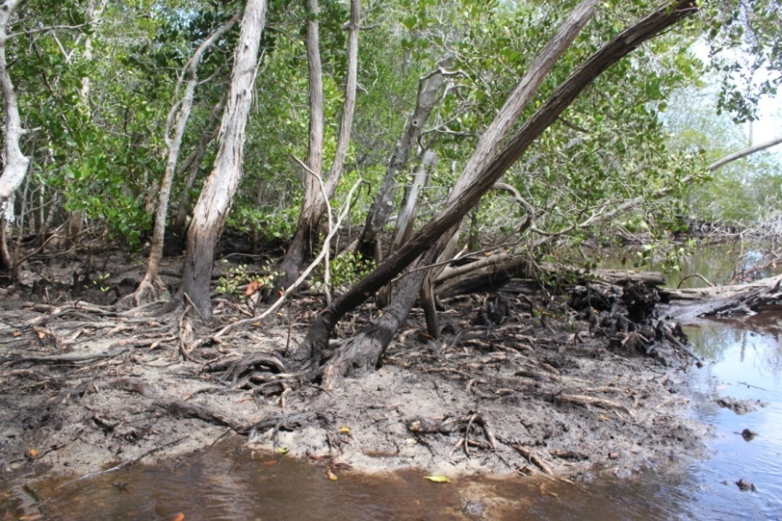

Figure 1. Habitat feature of *O. octodonta* in Panua Nature Reserve.

It is confirmed from the field observation that most of *O. octodonta* plants are found as shrub with canopy height less than 7 meters. This plant has grey, spongy flaking and quite thick bark and with irregular slender trunk. The plant has aromatic leaf in obavate shape, and with opposite leaves position. Fruit is a globose. Roots is unspecialised, develop obscure buttresses and spongy bark in large diameter. In Figure 2 several parts of the specimen of *O. octodonta* collected from Panua Nature Reserved is illustrated.

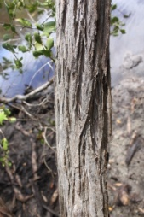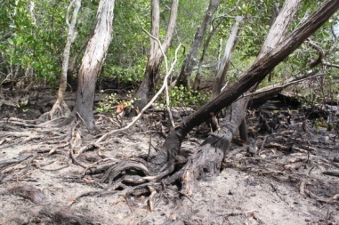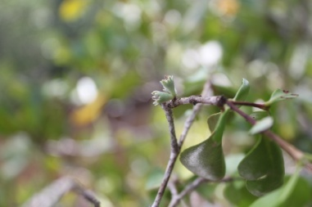

(a)a

(b)a)

(c)a)

**Figure 2**. *Osbornia octodonta* (Myrtaceae): (a) grey, spongy flaking and quite thick bark, (b) exposed root, (c) shoot with fruit.

Another mangrove species that is uncommon in Tomini Bay is *Bruguiera cylindrica*. Along the coastal environments of the Bay, this species occur only at specific locations at Malakosa and Sausu Piore in Parigi Moutong District. These locations are indicated in the table 1 to have habitat type 8 (highly accreting inland fringe) or type 9 (seasonally or regularly freshwater influenced). In these locations, the habitat is subjected to sedimentation and can be reached by seawater at spring tide. Substrate in this habitat is newly established and is expected to be inundated by freshwater during rainy season. Similar habitat condition where this species occur has been reported by Davie *et al.* (1996), Djamaluddin (2004) and Djamaluddin (2014) for mangrove in Mantehage Island Bunaken National Park. There may be a special condition that controls the establishment of this species on the described habitat, and this needs further investigation. Figure 3 shows any parts of *B. cylindrica* specimen collected from Malakosa.

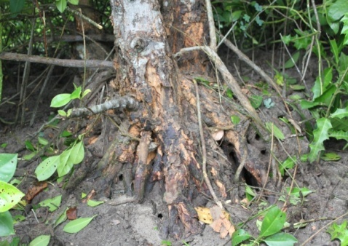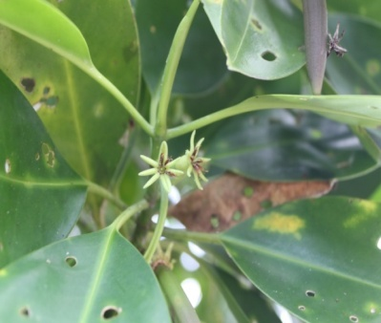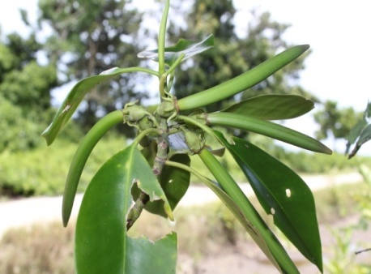

(c)

(b)

(a)

Figure 3. *Bruguiera cylindrica* (Rhizophoraceae): (a) root system, (b) shoot with open flower, (c) hypocotyls.

**Conclusion**

The mangrove flora in Tomini Bay comprises of at least 27 species comparing to 32 species listed by Tomlinson (1986) for the broader longitudinal biogeographic region between 120o and 135o E. Species of *Avicennia marina, Bruguiera gymnorrhiza, Rhizophora apiculata* are very common, meanwhile three species of *Bruguiera cylindrica*, *Osbornia octodonta,* and *Heritiera globulus* seemto be typical mangrove species in the Bay. Other species may occur at specific environmental conditions but they are in big population such as *Ceriops tagal, Pempis acidula, Sonneratia alba* and *Schyphiphora hydrophyllacea*.

Two rare species of *O. octodonta* and *B. cylindrical* were identified to occur in Tomini Bay. Trees of *O. octodonta* have developed to form shrub formation with canopy height less than 7 meters, and they are particularly inhabited small area in Panua Nature Reserve that is usually inundated by seawater at spring tide, remaining inundated at low tide, seasonally influence by freshwater during rainy season, and has a wide range of salinity. Trees of *B. cylindrica* occur only at two locations of Malakosa and Sausu Piore at Parigi Moutong District. This species grows on habitat of highly accreting inland fringe and seasonally or regularly freshwater influenced with newly established substrate.

**References**

Balanchandra L.1988. A comprehensive account of of the mangrove vegetation of Andaman and Nicobar Islands. The Indian Forester, 114(11):741-751.

Blasco F. 1984. Taxonomic considerations of the mangrove species. In: Snedaker,SC, Snedaker JG. (Eds.). 'The Mangrove Ecosystem: Research Methods', UNESCO. pp 81-90

Bunt JS. 1996. Mangrove zonation: an examination of data from seventeen riverine estuaries in tropical Australia. Ann Bot., 78:333-341.

Chapman VJ.1975. Mangrove biogeography. In: Walsh GE, Snedaker SC, Teas HJ. (Eds.). 'Proceedings of the International Symposium on Biology and Management of Mangrove'. Univ. Florida, Gainesville. pp 3 – 22.

Clarke LD, Hannon NJ.1969. Mangrove swamp and salt marsh communities of the Sydney District: the holocoenotic complex with particular reference to physiography. J. Ecology, 57:213-234.

Damanik R, Djamaluddin R. 2012. Atlas mangrove Teluk Tomini. Program Susclam (Sustainable Coastal Livelihoods and Management Program.CIDA, IUCN, Lestari Canada.91 p.

Davie J, Merril R, Djamaluddin R. 1996. The sustainable use and conservation of the mangrove ecosystem of the Bunaken National Park, Indonesia. Final Report to the Indonesia Natural Resource Management Project. USAID/ARD. Jakarta (Indonesia).

Ding Hou. 1958. Rhizophoraceae. Flora Malesiana, I(5):429-493.

Djamaluddin R. 2004. The dunamics of mangrove forest in relation to die-back and human use in Bunaken National Park, North Sulawesi, Indonesia. Doctoral thesis in the University of Queensland. Australia. 327 p.

Djamaluddin R. 2014. Penelitian kondisi mangrove di Pulau Mantehage. Balai Taman Nasional Bunaken. Manado (Indonesia). 45 p.

Duke NC.1991. A systematic revision of the mangrove genus *Avicennia* (Avicenniaceae) in Australia. Aus Sys Botany, 4:299-324.

Duke NC, Ball MC, Ellison JC. 1998. Factor influencing biodiversity and distribution gradients in mangrove. *Global Ecology and Biogegraphy Letters,* 7(1):27-47.

Fernado ES, Pancho JV. 1990. Mangrove trees of the Philippines. Silvatrop Philipp. For.Res.J*.,* 5(1):35-54.

Mabberley CM, Pannel CM, Sing A.M.1995. Flora Malesiana:seri I – Spermathophyata. 12(1):371-381.

Percival M, Womersley,JS. 1975. Floristics and ecology of the mangrove vegetation in Papua New Guinea. *Bot. Bull*., No. 8., Department of Forests, Division of Botany, Lee, Papua New Guinea.

Steenis CGGJ van. 1936. Osbornia octodonta, een weinig bekende mangrove-boom. Trop. Nat. 25:194-196.

Steenis CGGJ van. 1955 - 1958. Flora Malesiana. Djakarta; Noordhoff-Kolff NV. Pp 472-473

Thom BG.1967. Mangrove ecology and deltaic geomorphology, Tobasco, Mexico. J. Ecology, 55:301-343.

Thom BG. 1982. Mangrove ecology - a geomorphological perspective. In: Clough BF. (Ed.). 'Mangrove ecosystem in Australia: Structure, Function and Management'. Canberra (Australia); AIMS with ANU press. pp 3 – 17.

Tomlinson PB.1986. The botany of mangroves. NY: Cambridge University Press. 413 p.