Reproduction Characteristics of Tropical Eel *Anguilla bicolor* McClelland in Different Developmental Stage

FN Rachmawati and Y Sistina

Faculty of Biology Universitas Jenderal Soedirman

E-mail: faridanur12@gmail.com

**Abstract**. The reproductive characters provide information about the gonad maturity of eel. The prepubertal stage occurs in the yellow eel, and the pubertal stage achieves in the silver eel. This study aimed to evaluate the reproductive characters of tropical eel, *Anguilla bicolor* McClelland in the different developmental stages. Eels with 33-81 cm ± 13.54 length and 98 -1062 g ±262.99 were used to determine their reproductive characters. The variables observed were total length, body weight, Gonadosomatic Index (GSI), eye index and estradiol levels. The results showed that total length, body weight and GSI of silver eel were higher than yellow eel (P<0.01). Total length, body weight and GSI were 66.09 cm ±9.34; 556.83 g ± 236.24 and 2.12% ± 1.88 respectively. The eye index and plasma estradiol level of yellow eel, pre-silver and silver eel were similar (P>0.05). It was concluded that there are many differences of reproduction characteristics between yellow eel and silver eel.The gonad of silver eel has more mature than yellow eel.

1. Introduction

*Anguilla bicolor* McClelland is one of the Catadromous species which has an interesting life cycle. They start from a leptocephalus which changes to glass eel, then they migrate to the freshwater from the seawater to growth until they reach puberty. The developmental stage of eel can be divided into three categories that are, yellow eel, pre-silver and silver [1]. Metamorphose of the eel from yellow eel to the silver eel occur in the freshwater, then after they become silver eel, they prepare to migrate to the seawater for spawning.

During migrating, the eel completed their gonad maturity by changing reproductive character such as increasing the gonad weight, the diameter of eye, fin, and concentration of steroid hormone. This study has been done in *Anguilla anguilla* [2, 3]. The process of reproductive characters changing before migrating is known a silvering [4]. Silvering is identic with the maturation of gonad [5]. The important parameter to observe the gonad maturity of the eel are eye index, fin index, GSI, body colouring, and concentration of steroid.

Lack of information about the change of reproductive character of eel in the different developmental stage. This information is important to know the gonad maturity in every developmental stage. This study aimed to evaluate the reproductive characters of tropical eel, *Anguilla bicolor* McClelland in the different developmental stages and to evaluate their gonad maturity.

1. Methods

The research was conducted at the Animal Physiology Laboratory, Faculty of Biology UNSOED. The eel was obtained from a fisherman in the Pesanggrahan village, Cilacap. Fish acclimated for about a day on the aquarium fibbers (100 x 100 x 130 cm 3) filled with 300 l water to eliminate stress during transportation. After the acclimation, fish was grouped base on their stage development that are: yellow eel, pre-silver eel and silver eel. Fish were anesthetized with clove oil 5ppm for about 30 minutes [6]. Then, they were weighed and the blood was drawn by syringe. The length body was measured using a ruler, eye diameter, and pectoral fin length were measured using calliper. Fish were dissected through the abdomen from the anus to the pectoral for gonad isolation. Gonad was weighed using an analytical scale (Explorer OHAUS) for measuring the GSI (Gonadosomatic Index).

The observed variables were Eye Index, Fin Index, Gonadosomatic Index (GSI) and serum concentration of estradiol

The blood obtained was transferred into Eppendorf tubes, the allowed at room temperature for 30 minutes. Then, it was stored for ±12 hours at 4º C refrigerator, until centrifuged in Eppendorf Centrifuge 5415 for 15 minutes at 3500 rpm to get the serum. Serum obtained was transferred into new Eppendorf tube and stored in Glacier Ultralow Temperature Freezers (Plymouth, USA), until estradiol measurement (Kit 17 β-estradiol REF 30 330 - Bio Marieux Inc., France).

To get eye diameter, the horizontal (A) and vertical diameter (B) of the orbital eye were measured using calliper. Eye Index is [(A+B)/4] 2 x π/body length (mm) x 100 [7]. Measurement of pectoral fin length using calliper by measuring the length of the fins (FL) ranging from base to tip. Fin Index is FL (mm)/body length (mm) x 100 [7].

The calculation of GSI value refers to Rupia *et al*. [8]. GSI: (gonad weight/body weight) x 100. The gonads were fixed in NBF solution for paraffin Methods preparation gonad sample follow by Haematoxylin-Eosin was done at Research Laboratory of Faculty of Medicine UNSOED. The analyses of gonadal histology structure refer to Arai and Kadir [9] to evaluate sex and gonad maturity status.

Data obtained from this research: body length, body weight, eye index, fin index, GSI and concentration of estradiol were analysed by one-way ANOVA [10].

1. Results

There were three stages of *A. bicolor* based on their colour body especially in their abdomen. Yellow eel has a yellow abdomen, pre-silver has silver abdomen but not fully colour like silver eel, in contrast, the silver eel has abdomen with fully silver colour. The eye index and estradiol concentration of eel in the different developmental stage were similar. GSI of pre-silver and silver were similar but they were bigger than the GSI of yellow eel (Figure 3). GSI of *A. bicolor* in this study were 0.88% (yellow eel), 2,034% (pre-silver) and 2,143% (silver eel).

The body length of yellow eel, pre-silver and silver eel were 44.1 cm ± 10.3591; 52.54 ± 13.0845 and 66.0913 ± 9.5514. The body length and the body weight tend to increase from yellow eel to silver eel (Figure 1). Whereas the eye index and estradiol concentration of eel in the different developmental stage were similar, that is 9.3786 ± 4480 (Figure 3), 9.2380 ± 4.5820 and 7.1530 ± 2.7437 for Eye Index (Figure 4). Yellow eel are juvenile stage of the eel, they have body length about 20 cm – 45 cm. Estradiol concentration of eel in different developmental stage were also similar like eye index, that are 0.1687 ng/ml ± 0.2330; 0.1206 ng/ml ± 0.1174 and 0.3024 ng/ml ± 0.3391.

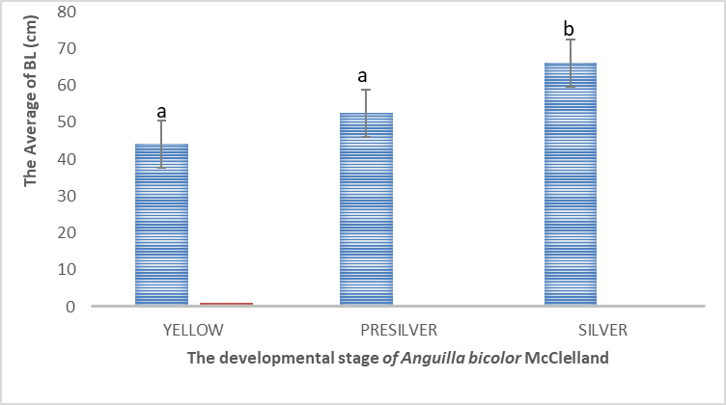

Figure 1. The average of body length (cm) of *Anguilla bicolor* McClelland in the different developmental stage

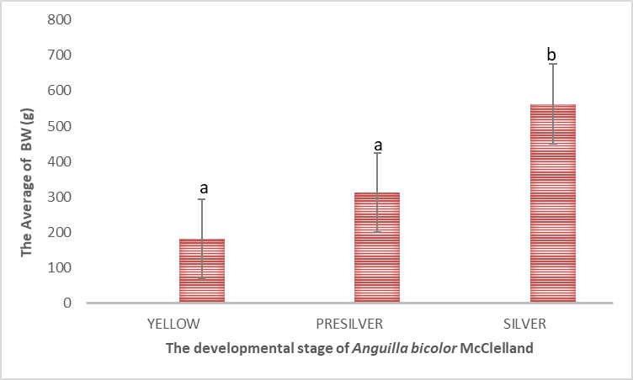

Figure 2. The average of body weight (g) of *Anguilla bicolor* McClelland in the different developmental stage

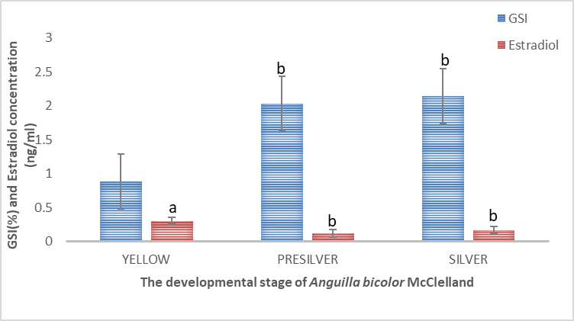

Figure 3. The average of GSI (%) and estradiol concentration of *Anguilla bicolor* in the different developmental stage.

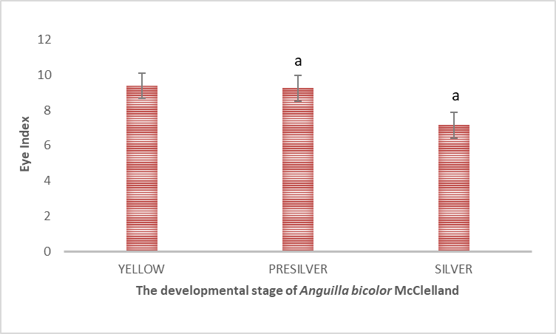

Figure 4. The average of Eye Index of *Anguilla bicolor* in the different developmental stage.

1. Discussion

The reproductive characters of eel in different developmental stage in this research were similar except the GSI which increased in the puberty phase (Pre-silver and silver eel). Generally, GSI, eye index and steroid concentration of eel will increase during silvering and migration [3].

GSI of eel prior to migration will increase, and reach maximum when spawning. Before migrating, GSI will reach 40 % in female and 10% in male [11]. Pre-silver and silver eel before migration / prepubertal stage have GSI 0-3% in female and 1-9% male of *Anguilla bicolor* [12,13,6].

Estradiol concentration in yellow, pre-silver and silver eel of *A. bicolor* is low (0.1206 ng/ml - 0.3024 ng/ml). Estradiol concentration will increase during silvering/migration [3] before migration concentration of this hormone is low. *A. bicolor* < 0.5 ng/ml [6]. During maturation, estradiol concentration of *A. japonica* is about 5.82ng/ml. This concentration is higher than prepubertal stage [16].

Yellow, pre-silver and silver eel of *A. bicolor* have similar reproductive characters except the size and GSI. Its mean that *A. bicolor* have smallest size in yellow stage, whereas in the silver eel, their size is biggest. These characters can determine the stage of their developmental.

Eye index more increase during silvering/migration, their eyes enlarge because they exposure with high salinity environment. Eye index not only show the gonad maturity but during metamorphosis from yellow to silver their size increase similar with eye diameter [14]. Eel at puberty stage (silver eel) have eye index > 7 [15]. In this research, the eye index is similar in all developmental stage, that are more than 7. In general, yellow eel has eye index < 7, whereas silver eel has eye index > 7. In this research, yellow eel of *Anguilla bicolor* has body length 44.1 cm ± 10.3591 and eye index more than 7. Yellow eel is a juvenile stage of the eel, they have body length about 20 cm – 45 cm. Furthermore, the eye index of yellow eel in this research can reach more than 7. In general, eye index of yellow eel which have body length about 20 -30 cm is less than 7.

Conclusion

It was concluded that there are many differences of reproduction characteristics between yellow eel and silver eel. The gonad of silver eel has more mature than yellow eel.

References

1. Han, Y.S. I. Chio Liao, Y.S. Huang, J.T. He, C.W. Chang and W.N. Tzeng. 2003. Synchronous changes of morphology and gonadal development of silvering Japanese eel *Anguilla japonica. Aquaculture,* 219 ( 1-4) : 783 – 796**.**
2. Palstra, A.P., E.G.H. Cohen, P.R.W. Niemantsverdriet, V.J.T. van Ginneken and G.E.E.J.M. van den Thillart. 2005. Artificial maturation and reproduction of Europian silver eel : Development of oocytes during final maturation. *Aquaculture*, 249 (1-4) : 533-547.
3. Nowosad, J., D. Kucharczyk, T.K. Czarkowski and K. Kwasek. 2014. Changes in body weight and eye size in European eel kept in fresh and salt water. *Italian Journal of Animal Science****,*** 13 : 382 – 386.
4. Mordenti, O., A. Di Biase, G. Bastone, R. Sirri, A. Zaccaroni, A. Parmeggiani. 2013. Controlled reproduction in the wild Europena eel (*Anguilla anguilla*) : two populations compared. *Aquacult. Int*, 21: 1045-1063.
5. Palstra, A.P. and G.E.E.J.M. van den Thillart. 2010. Swimming physiology of European silver eels (*Anguilla anguilla* L.) : energetic costs and effects on sexual maturation and reproduction. *Fish Physiology Biochemistry,* 36 : 297 – 322.
6. **Rachmawati, F.N** dan U. Susilo. 2011. Profil Hormon dan Kinerja Reproduksi Ikan sidat, *Anguilla bicolor* McClelland. *Biota,*16 (2) : 221 – 226.
7. Yokouchi, K., R. Sudo, K. Kaifu, J. Aoyama and K. Tsukamoto. 2009. Biological Characteristics of Silver-Phase Japanese Eels, *Anguilla japonica* , Collected from Hamana Lake, Japan. *Coastal Marine Science****.*** 33 (1) : 1 – 10.
8. Rupia, E.J., J. Shen., J.Wu, W. Chen, L. Liu, K . Dierckens, P. Sorgeloos and W. Lu. 2013. Effect of hormone injection frequency on the lipid content and fatty acid compositions in gonad, muscle and liver of *Anguilla japonica* during artificial maturation. *Aquaculture International,*22 (3) :1105–1120
9. Arai, T, and S.R. Abdul Kadir. 2017. Opportunistic spawning of tropical anguillid eels *Anguilla bicolor bicolor* and *A. bengalensis bengalensis*. [*Internet]*. [cited 2017 Nov 30]; 7:41649. Available from: http://www.nature.com/Scientificreport/ doi: 10.1038/srep41649
10. Steel, R.G.D. and J.H. Torrie, 1981. *Principles and Procedures of Statistic a Biometrical Approach*. 2 nd. Mc Graw Hill Book Company, Singapore.
11. Tsukamoto, K., S. Chow, T. Otake, H Kurogi, N. Mochioka, M. Miller, J. Aoyama, S. Kimura, S. Watanabe, T. Yoshinaga, A. Shinoda, M. Kuroki, M. Oya, T. Watanabe, K. Hata, S. Ijiri, Y. Kazeto, K. Nomura and H. Tanaka. 2011. Oceanic spawning ecology of freshwater eels in the western North Pacific. *Nature Communications****,***  2 (179) : 1-9
12. Sugeha, H.Y., T. Arai, M.J. Miller, D. Limbong and K. Tsukamoto. 2009. Inshore migration of the tropical eels *Anguilla* spp. Recruiting to the Poigar river estuary on north Sulawesi island. *Marine Ecology* *Progress Series,* 221 : 233 243.
13. **Rachmawati, F.N** dan U. Susilo. 2009. Perkembangan Gonad Ikan Sidat, *Anguilla bicolor* Ditinjau dari Titer Hormon Gonadotrophin. *Sains Akuatik* 10 (2) : 148 – 154.
14. Tesch FW. (2003) The Eel. Blackwell Science, Oxford, UK, 408 pp
15. Beullens, K., E.H. Eding, P. Gilson, F. Ollevier, J. Komen and C.J.J. Richter. 1997. Gonadal differentiation, intersexuality and sex ratios of European eel (*Anguilla anguilla* L) maintained in captivity. *Aquaculture,* 153 (1-2) : 135 – 150.
16. Kim, D.J., J. Young Bae, E. Oh Kim. 2007. Change in sex steroid hormones and ovarian development during artificial maturation of female eel, *Anguilla japonica. Integrative Bioscience,* 11: 117-124